**Department of Computer Engineering TE Computer-A (2020-21 Sem I) Computer Networks Assignment 1 [Max Marks: 40]**

**Submitted by : Himanshu Shekhar Padhi (3325)**

* **STAR TOPOLOGY**

In star topology, all the cables run from the computers to a central location where they are all connected by a device called a hub/switch. It is a concentrated network, where the end points are directly reachable from a central location when network is expanded. Ethernet 10 base T is a popular network based on the star topology. For star topology we build network using five generic pc which are centrally connected to single switch 2950-24 using copper straight through cable.

**HUB**

Network Topology (Hub)

1. Drag and drop PC from End Devices.

2. Connect them with Copper Straight through cable.

3. Change display name with their IP addresses.

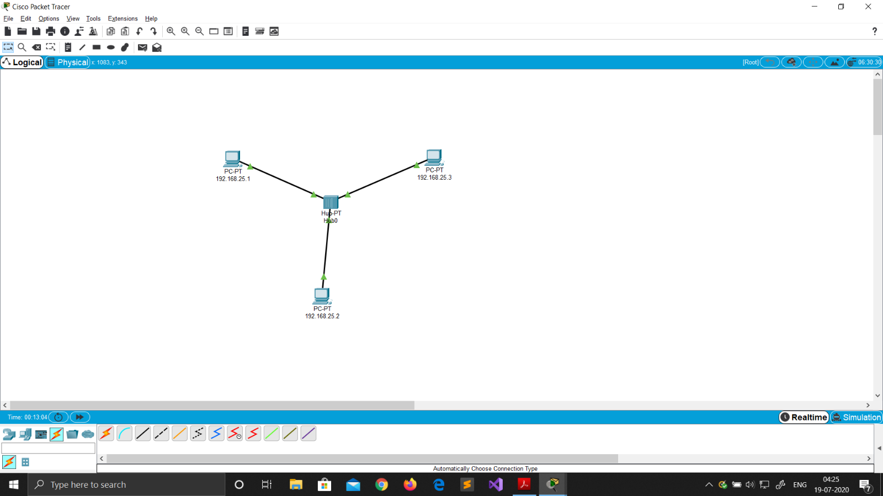

Ip Address Configuration (Hub)

1. Click on the device.

2. Go to Desktop ->IP configuration.

the device.

2. Go to Desktop ->IP configuration.

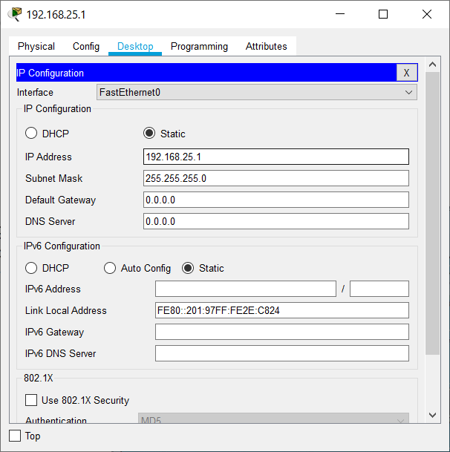3. Set static IPs of all devices. No gateway required (same network).

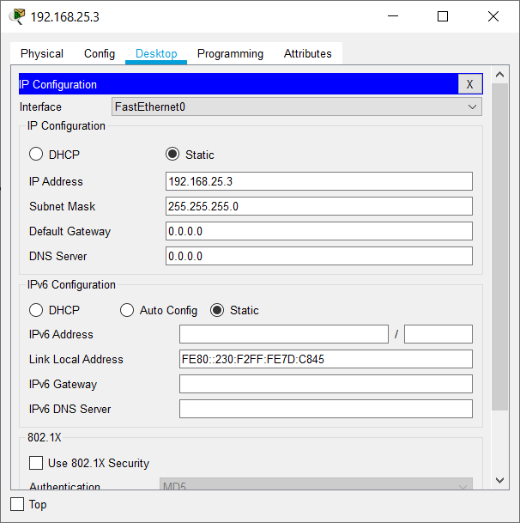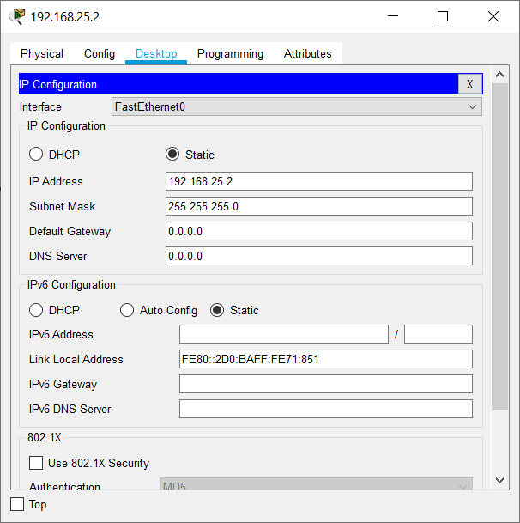

Ping Command (Hub)

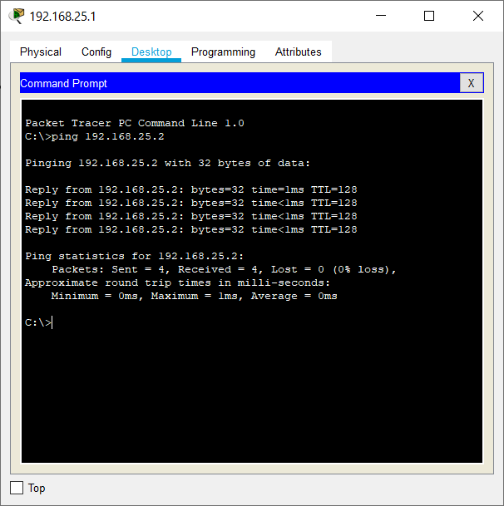1. Click on the device.

2. Go to Desktop -> Command Prompt.

3. Type ping ip_address.

Real Mode Simulation (Hub)

1. Click on simulation tab on bottom right corner.

2. Drop Simple PDU (P) on the source and destination.

3. Then click on the play button in the simulation window.

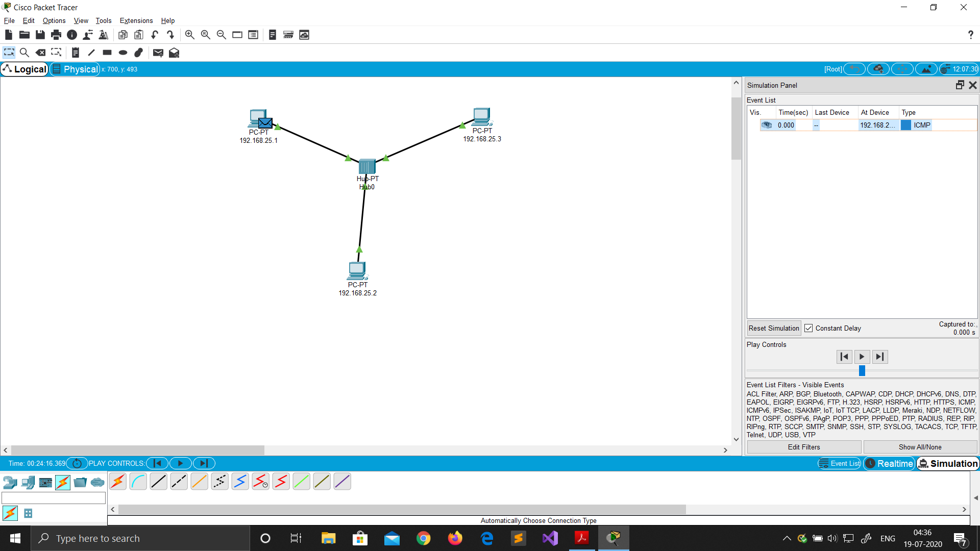

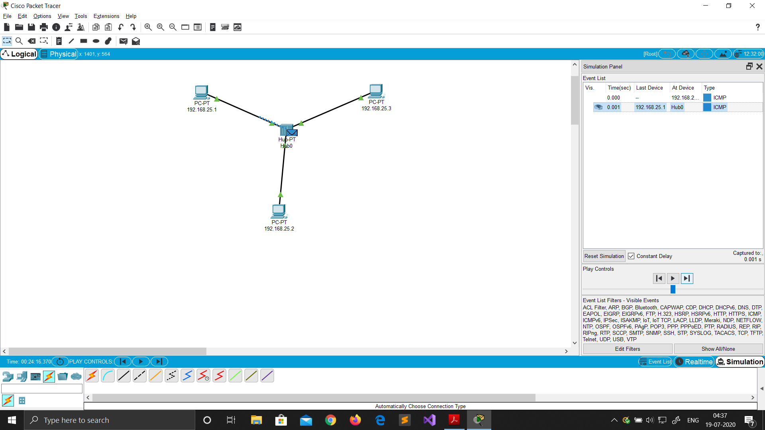

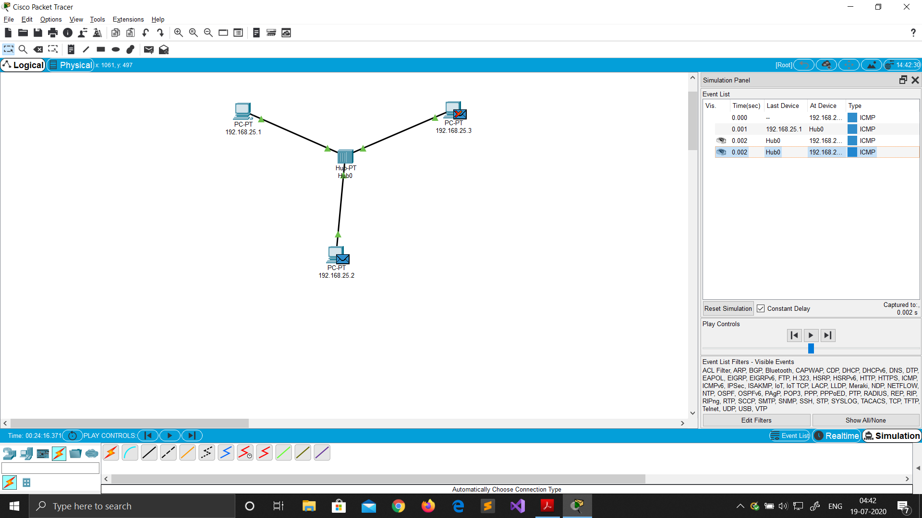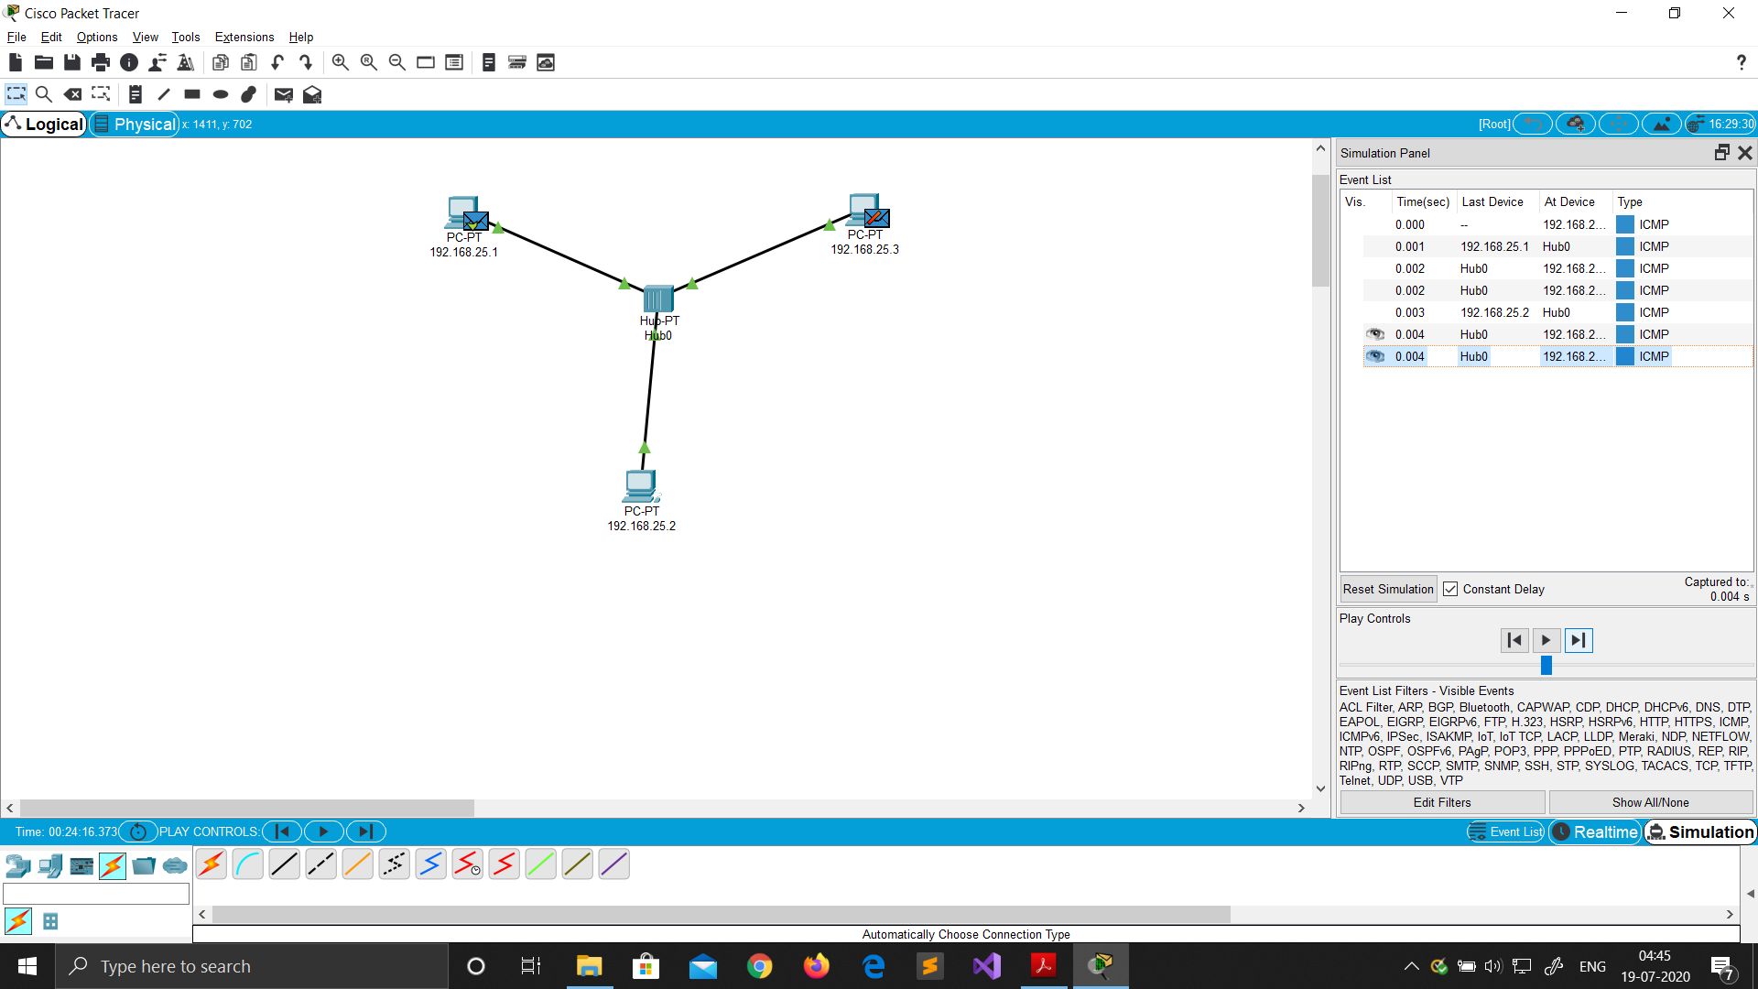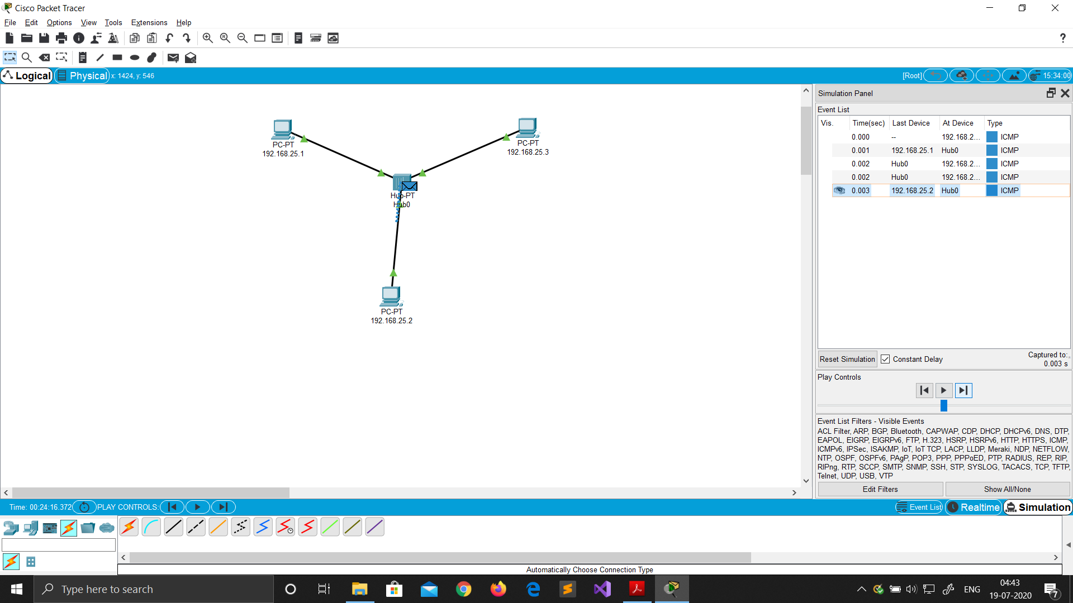

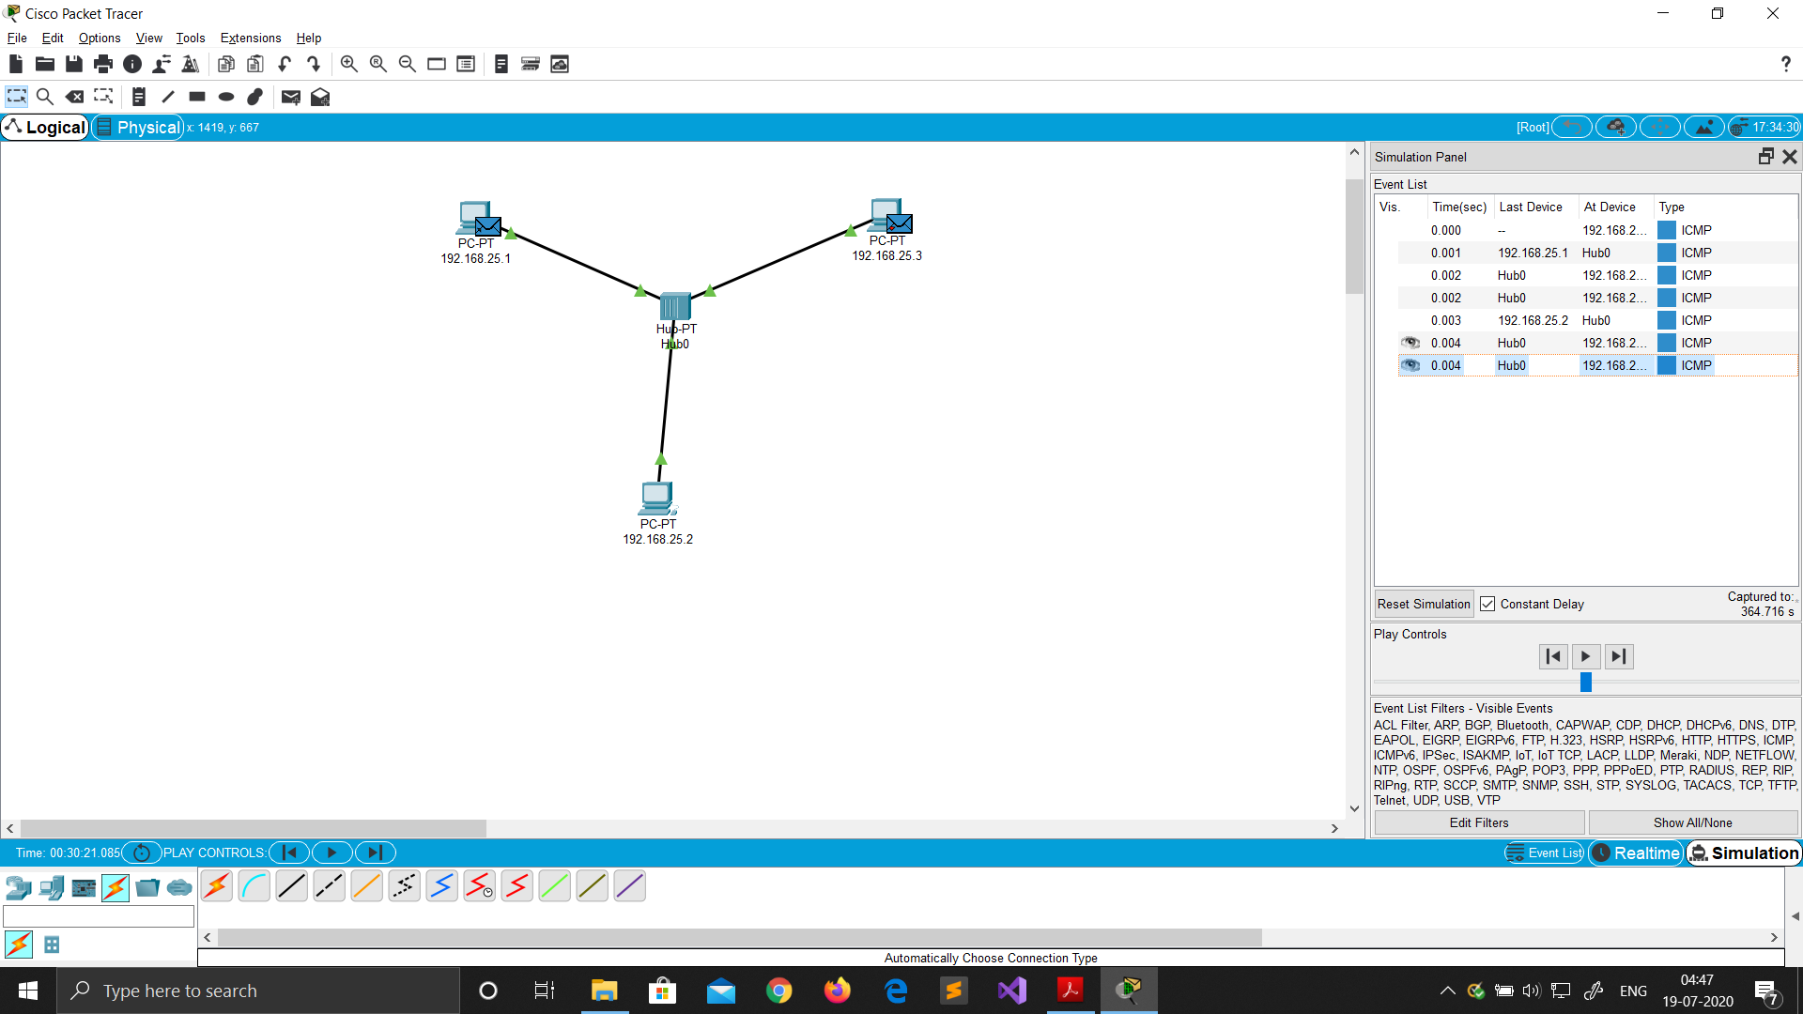

**SWITCH**

Network Topology (Switch)

1. Drag and drop PC from End Devices.

2. Connect them with Copper Straight through cable.

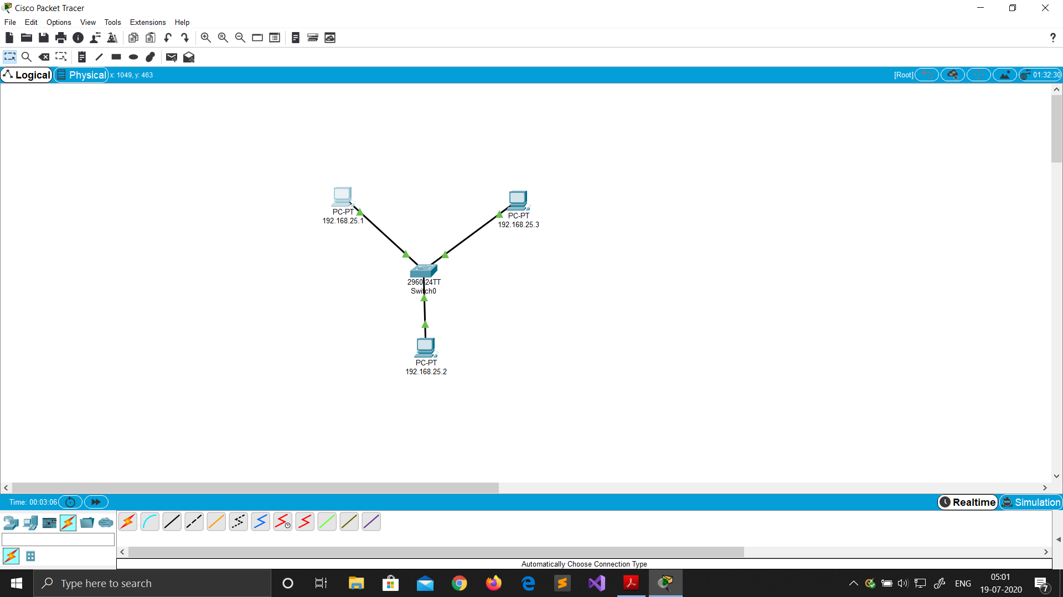3. Change display name with their IP addresses.

Ip Address Configuration (Switch)

1. Click on the device.

2. Go to Desktop ->IP configuration.

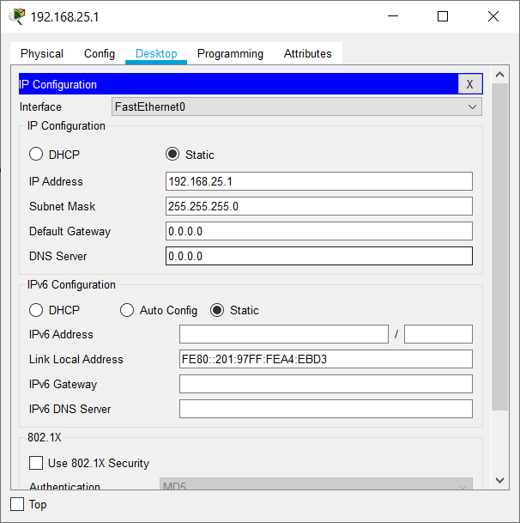3. Set static IPs of all devices. No gateway required (same network).

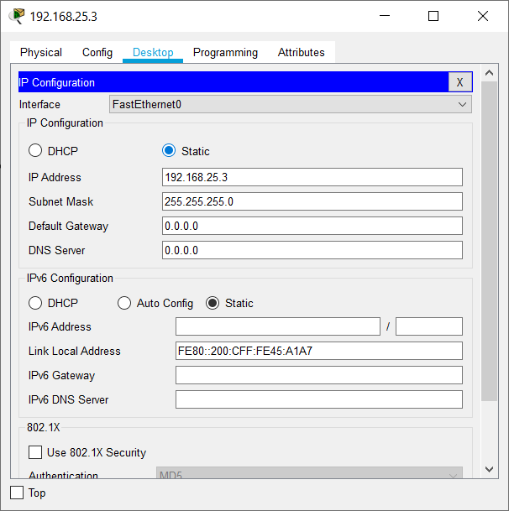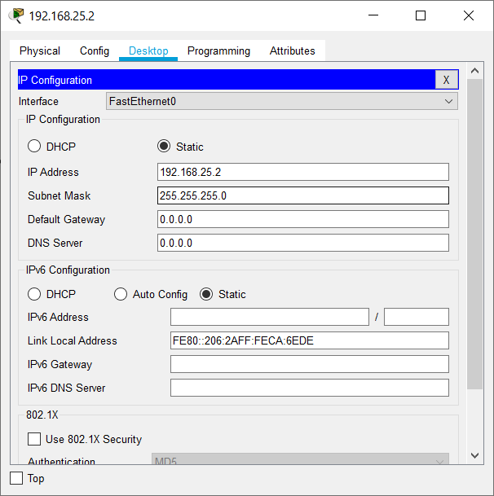

Ping Command (Switch)

1. Click on the device.

2. Go to Desktop -> Command Prompt.

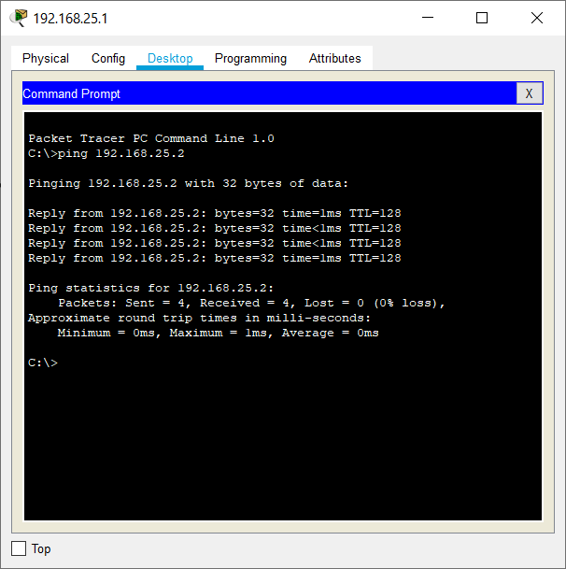3. Type ping ip_address.

Real Mode Simulation (Switch)

1. Click on simulation tab on bottom right corner.

2. Drop Simple PDU (P) on the source and destination.

3. Then click on the play button in the simulation window.

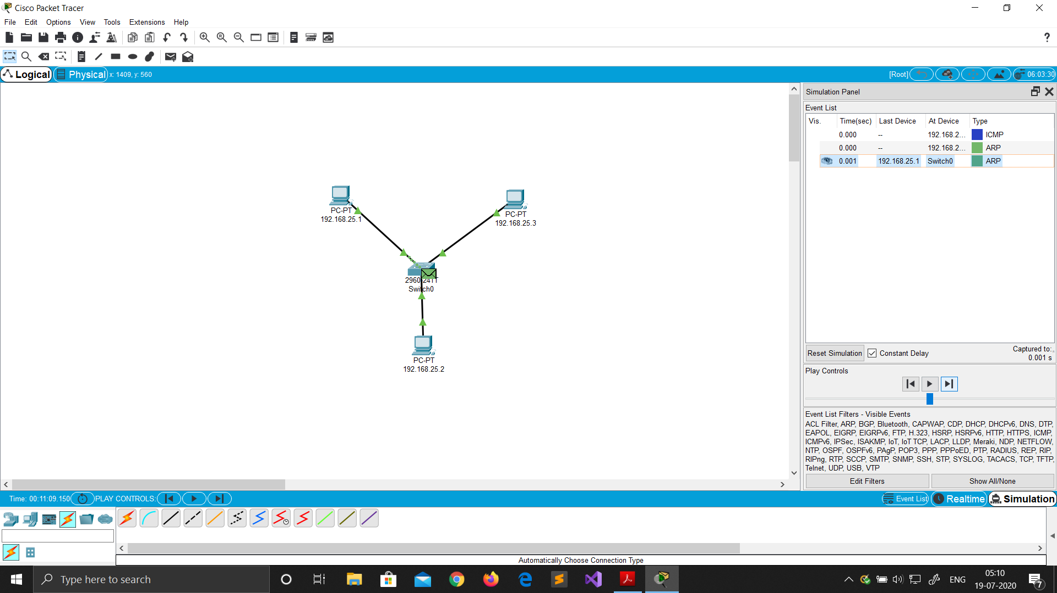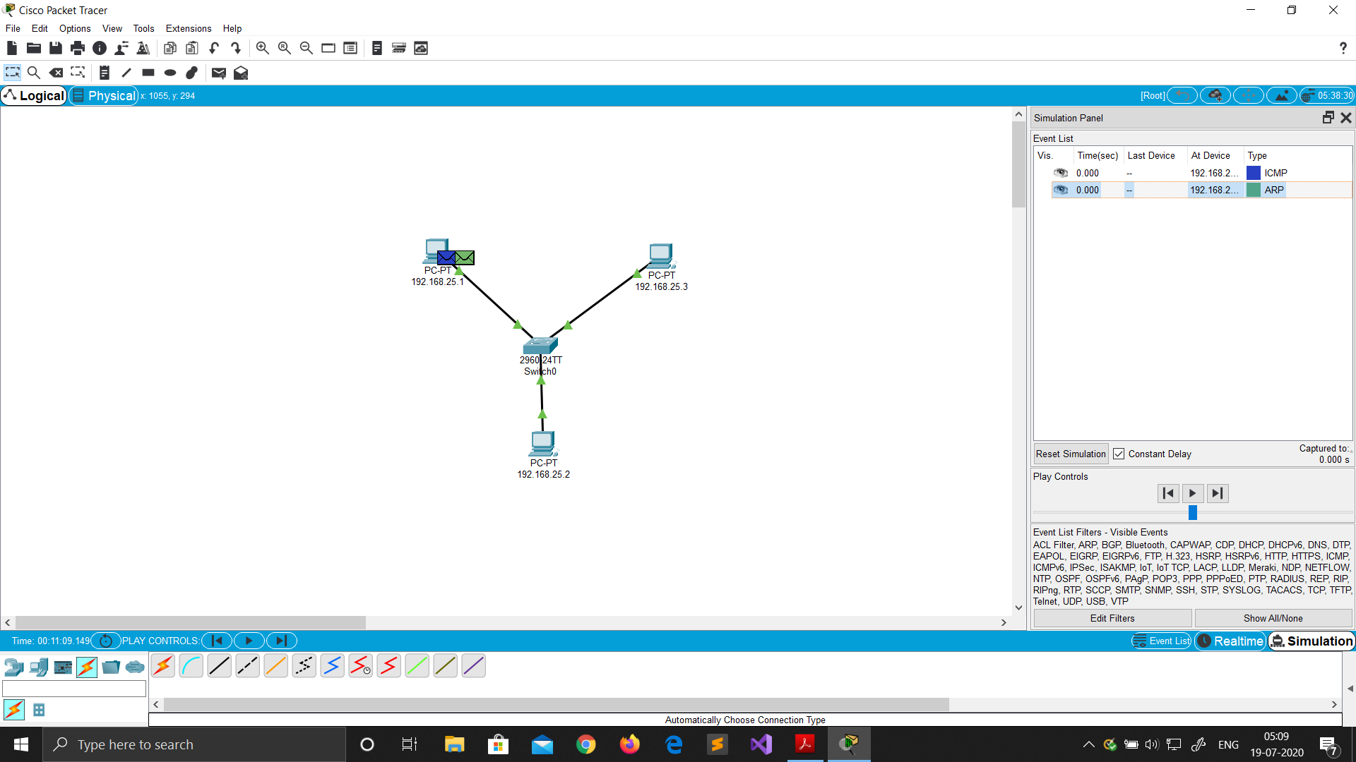

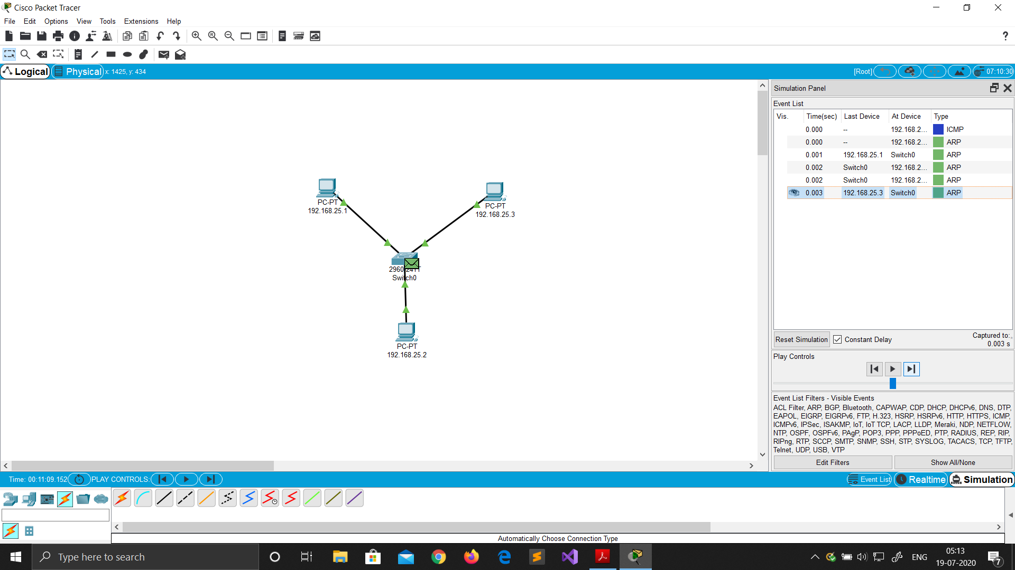

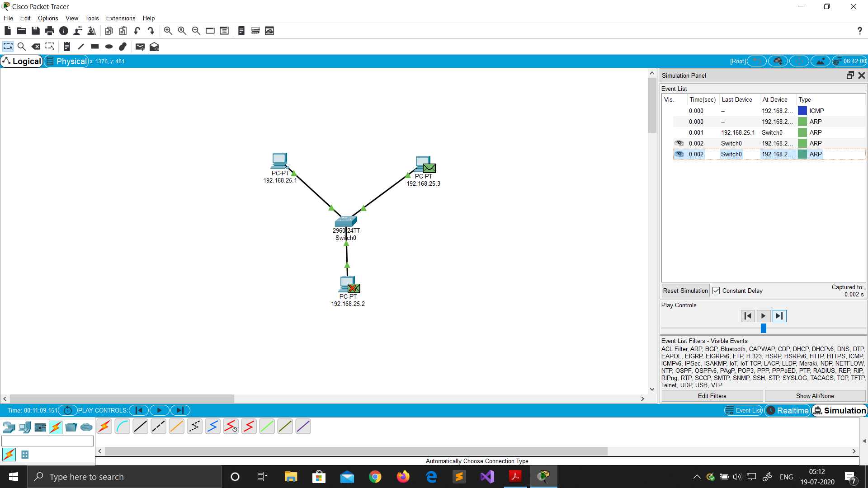

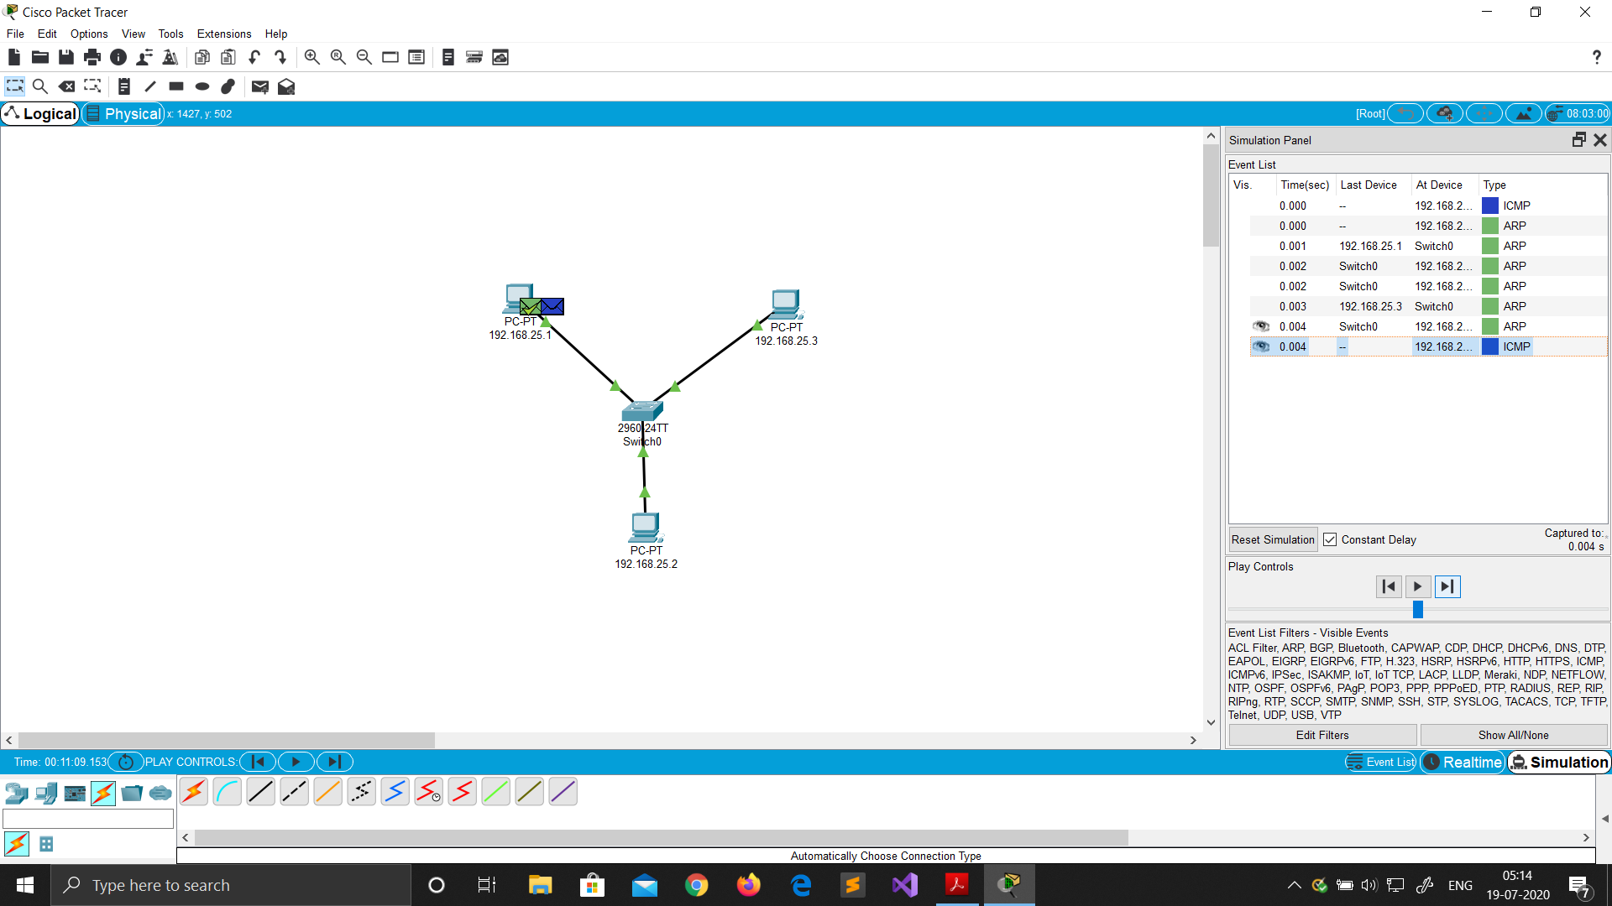

**Comparing Hub and Switch**

|  |  |
| --- | --- |
| **Hub** | **Switch** |
| A hub operates on the physical layer. | A switch operates on the data link layer. |
| Hubs perform frame flooding that can be unicast, multicast, or broadcast. | It performs broadcast, then the unicast and multicast as needed. |
| Just a singular domain of collision is present in a hub. | Varied ports have separate collision domains. |
| Transmission mode is Half-duplex | Transmission mode is Full duplex |
| Hubs operates as a Layer 1 devices per the OSI model. | Network switches help you to operate at Layer 2 of the OSI model. |
| To connect a network of personal computers should be joined through a central hub. | Allow connecting multiple devices and ports. |
| Uses electrical signal orbits | Uses frame & packet |
| Does not offer Spanning-Tree | Multiple Spanning-Tree is possible |
| Collisions occur mostly in setups using hubs. | No collisions occur in a full-duplex switch. |
| Hub is a passive device | A switch is an active device |
| A network hub can't store MAC addresses. | Switches use CAM (Content Accessible Memory) that can be accessed by ASIC (Application Specific Integrated Chips). |
| Not an intelligent device | Intelligent device |
| Its speed is up to 10 Mbps | 10/100 Mbps, 1 Gbps, 10 Gbps |
| Does not use software | Has software for administration |

Advantages of Star Topology

**•**Easy to install and wire.

**•**No disruptions to the network when connecting or removing devices.

**•**Easy to detect faults and to remove parts.

Disadvantages of Star Topology

**•**Requires more cable length than a linear bus topology.

**•**If the connecting network device (network switch) fails, nodes attached are disabled and cannot participate in computer network communication.

**•**More expensive than linear bus topology because of the cost of the connecting devices (network switches).

* **BUS TOPOLOGY**

In local area network, it is a single network cable runs in the building or campus and all nodes are connected along with this communication line with two endpoints called the bus or backbone. In other words, it is a multipoint data communication circuit that is easily control data flow between the computers because this configuration allows all stations to receive every transmission over the network.

Network Topology

1. Drag and drop PC from End Devices.

2. Connect them with Copper Straight through cable.

3. Change display name with their IP addresses.

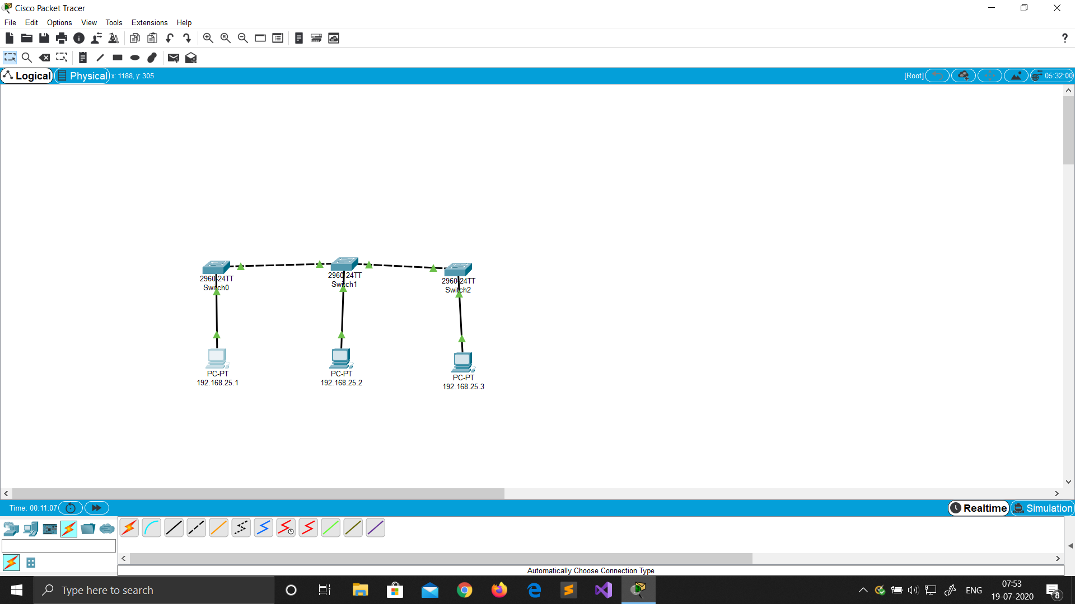

Ip Address Configuration

1. Click on the device.

2. Go to Desktop ->IP configuration.

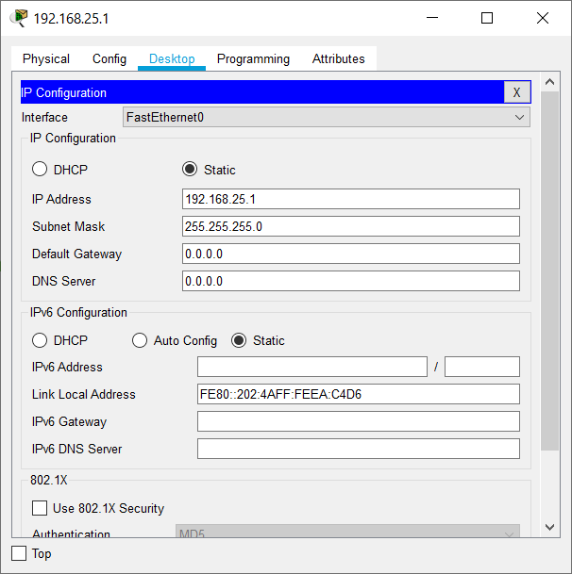3. Set static IPs of all devices. No gateway required (same network).



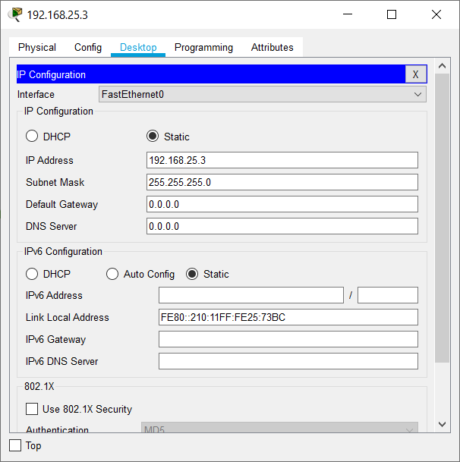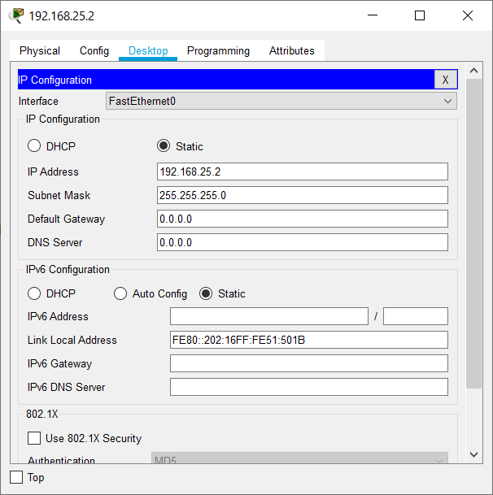

Ping Command

1. Click on the device.

2. Go to Desktop -> Command Prompt.

3. Type ping ip_address.

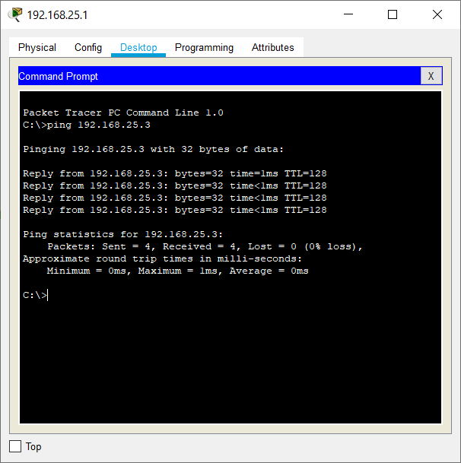

Real Mode Simulation

1. Click on simulation tab on bottom right corner.

2. Drop Simple PDU (P) on the source and destination.

3. Then click on the play button in the simulation window.

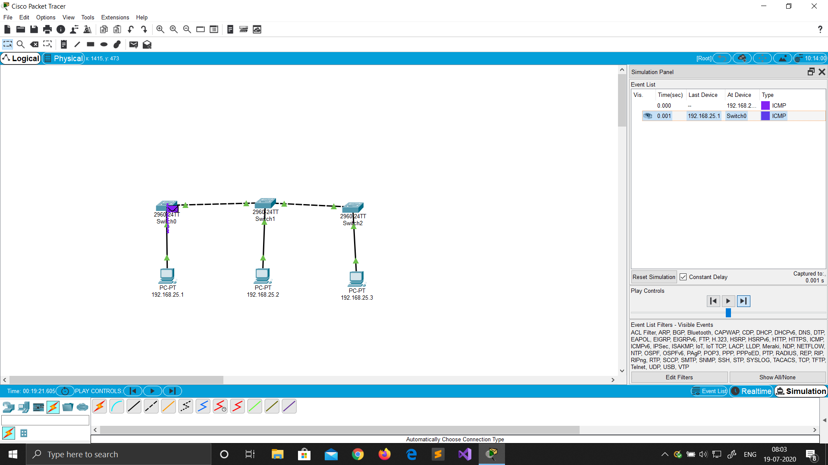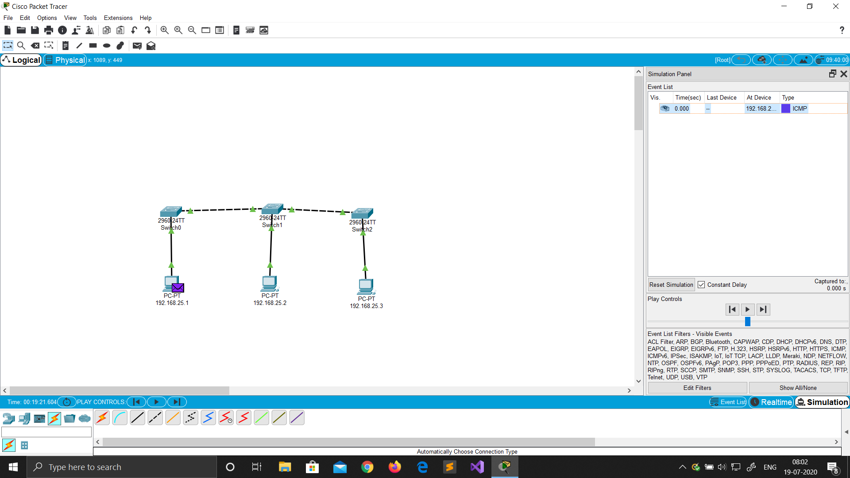

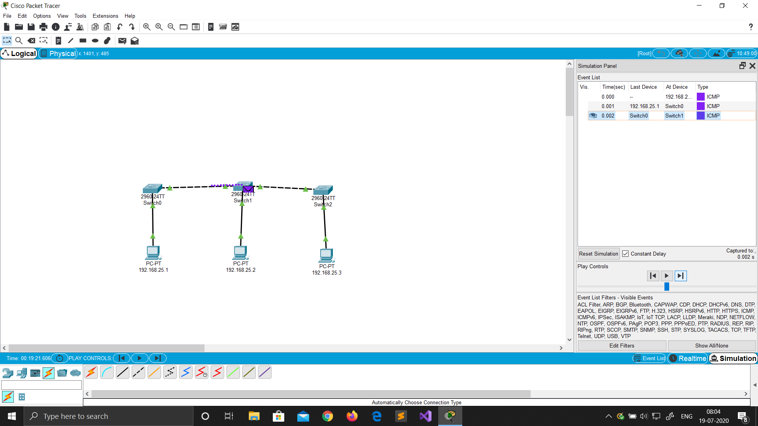

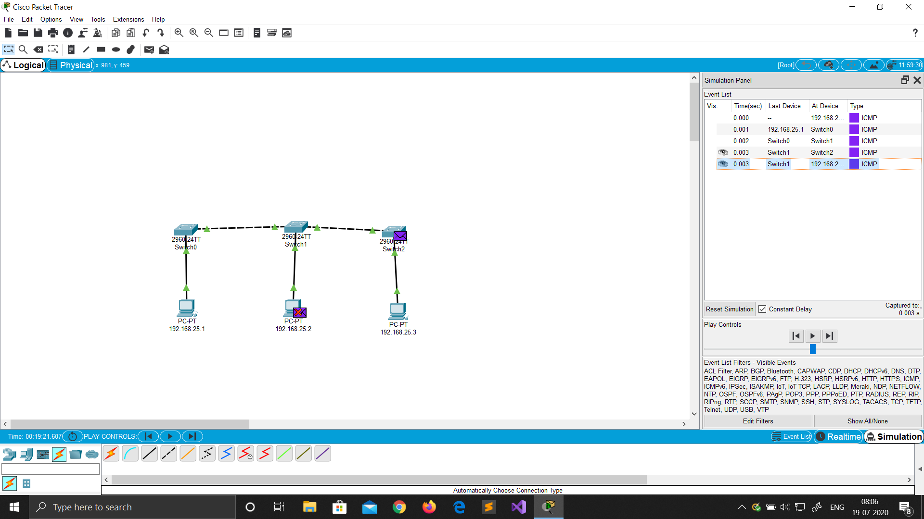

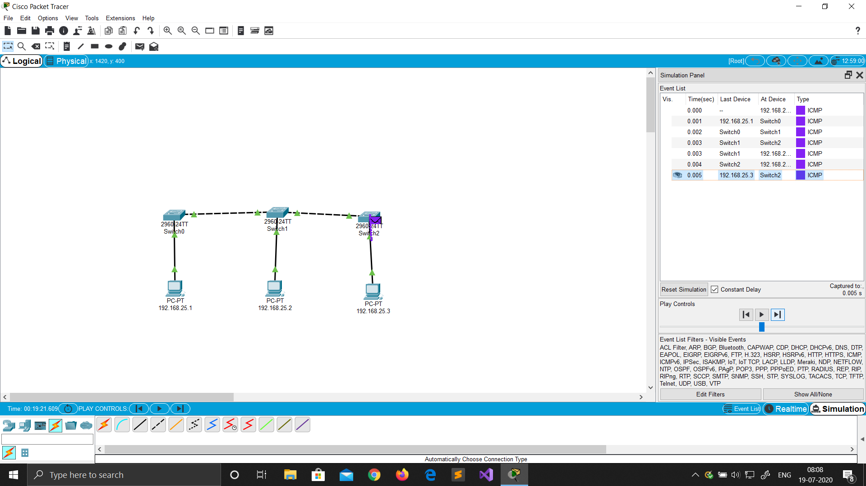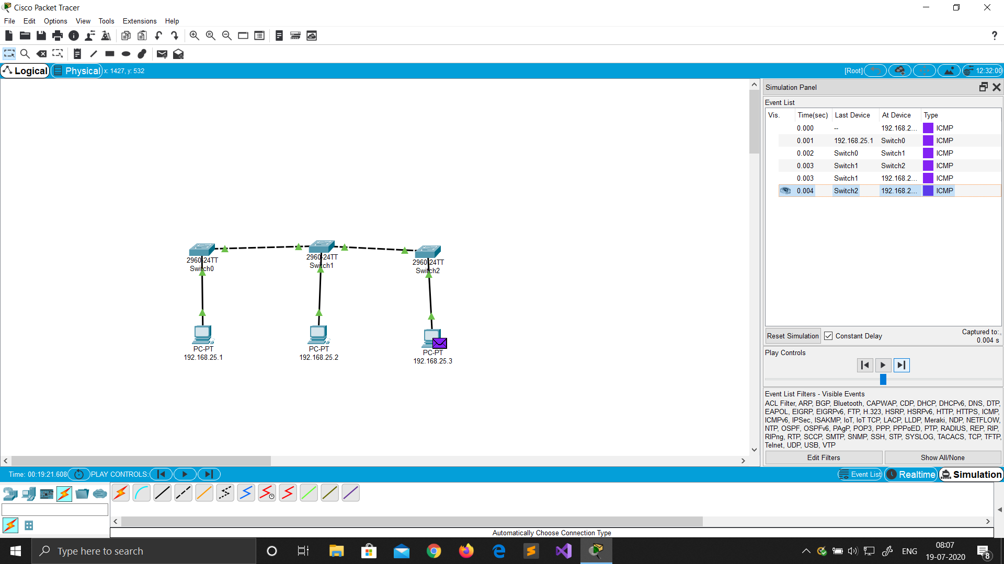

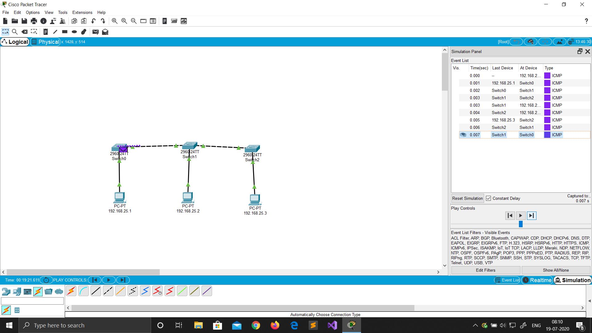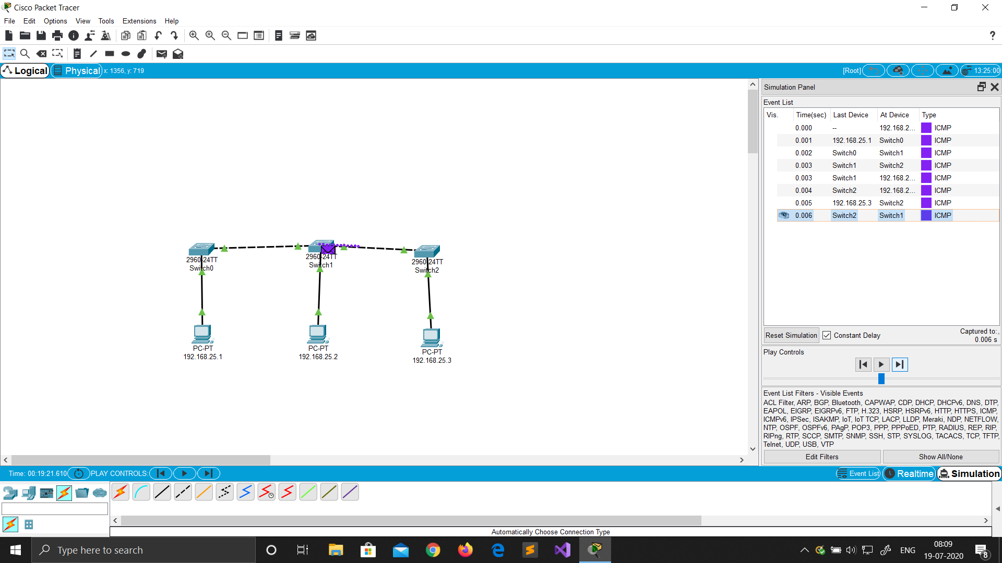

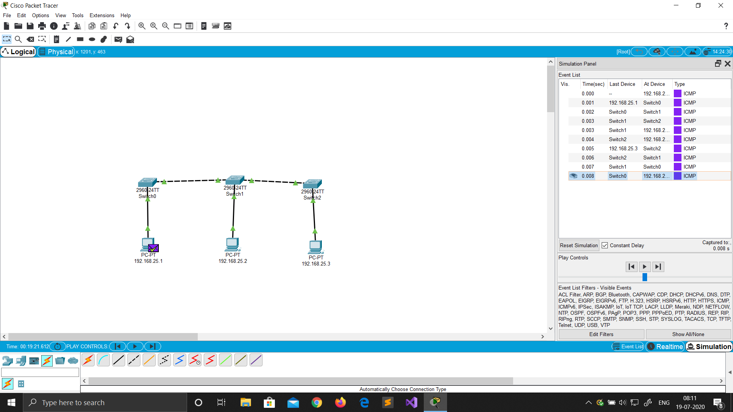

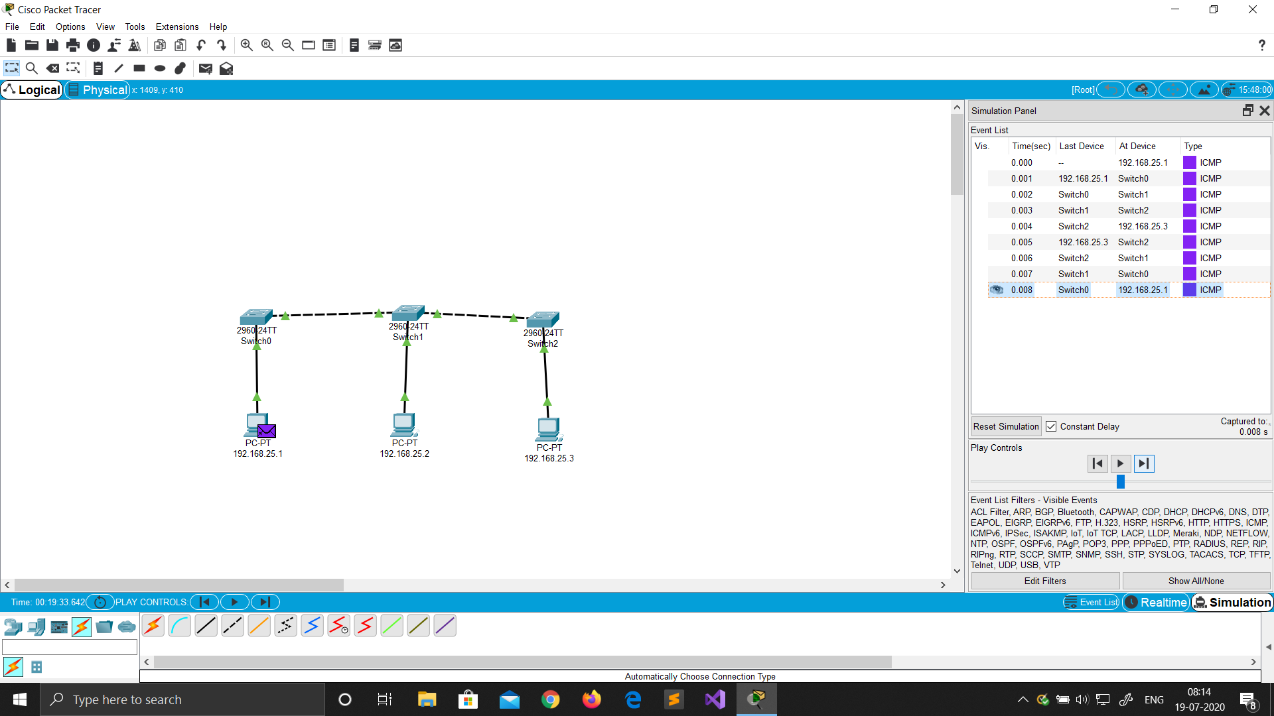

Advantages of Bus Topology

**•** Easy to connect a computer or peripheral to a linear bus.

**•** Requires less cable length than a star topology.

Disadvantages of Bus Topology

**•** Entire network shuts down if there is a break in the main cable.

**•** Terminators are required at both ends of the backbone cable.

**•** Difficult to identify the problem if the entire network shuts down.

**•** Not meant to be used as a stand-alone solution.

* **RING TOPOLOGY**

Ring topology, also known as Ring network, is a type of network topology where each node is exactly connected to two other nodes, forward and backward, thus forming a single continuous path for signal transmission.

There are two types of the Ring Topology based on the data flow:

* Unidirectional and,
* Bidirectional

A Unidirectional ring topology handles data traffic in either clockwise or anticlockwise direction. This data network, thus, can also be called as a half-duplex network. A Unidirectional ring topology is thus easy to maintain compared to the bidirectional ring topology.

Network Topology

1. Drag and drop PC from End Devices.

2. Connect them with Copper Straight through cable.

3. Change display name with their IP addresses.

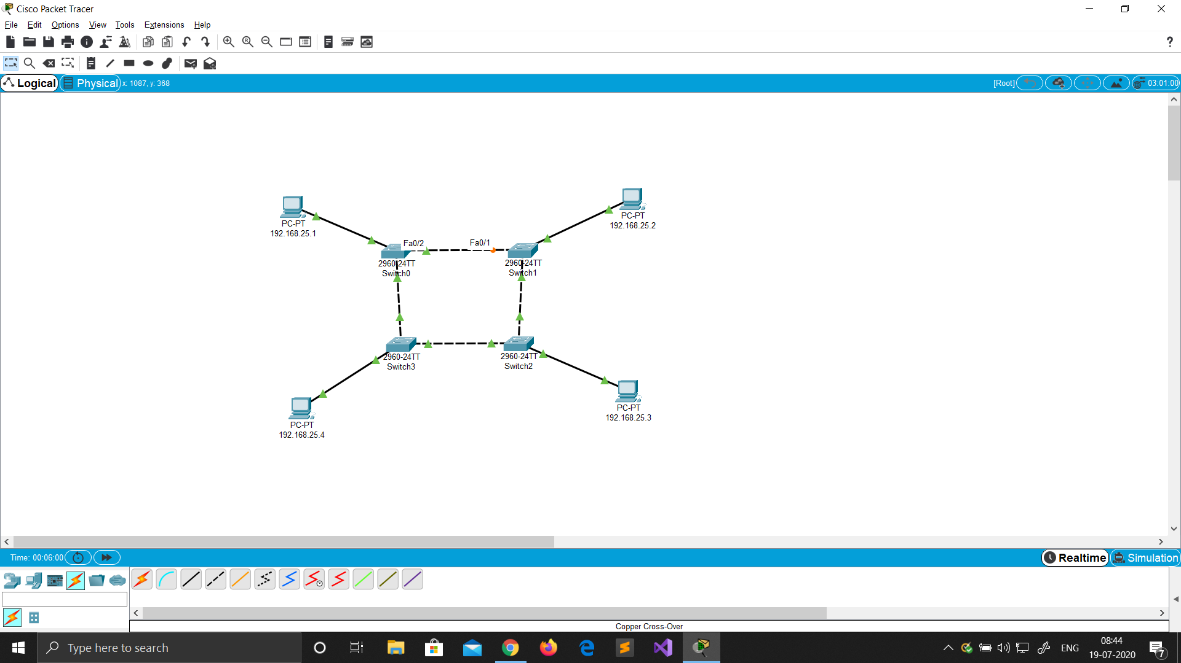

Ip Address Configuration

1. Click on the device.

2. Go to Desktop ->IP configuration.

3. Set static IPs of all devices. No gateway required (same network).

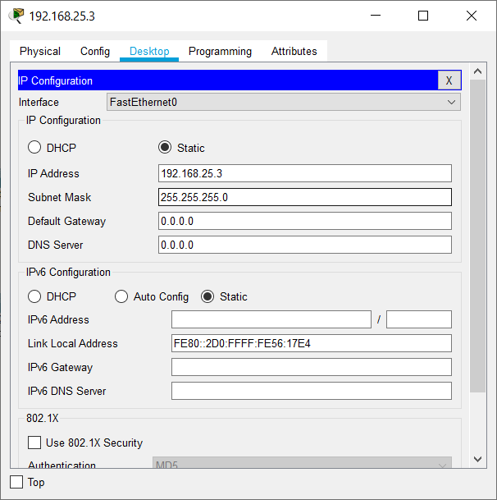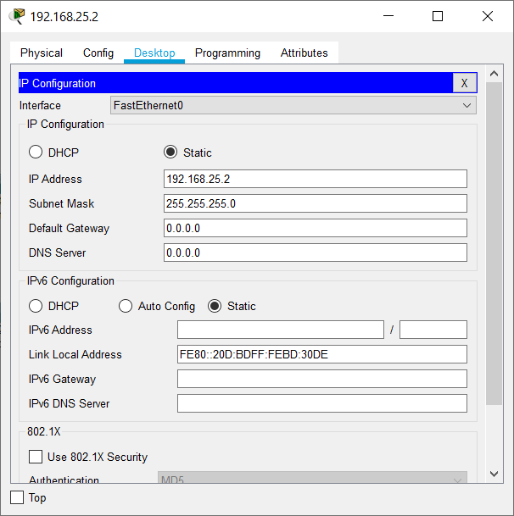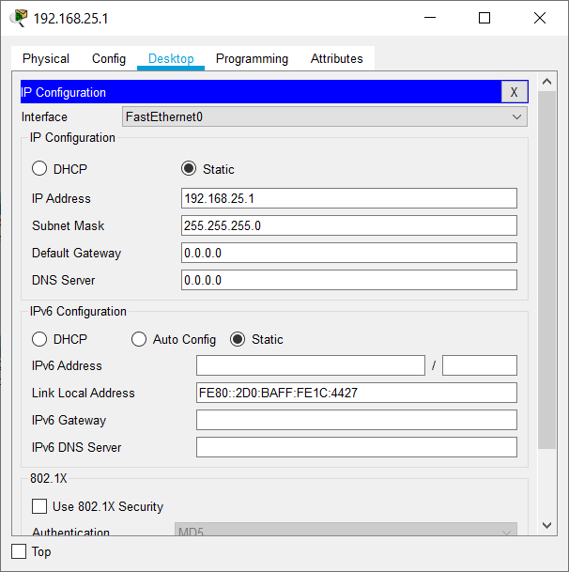

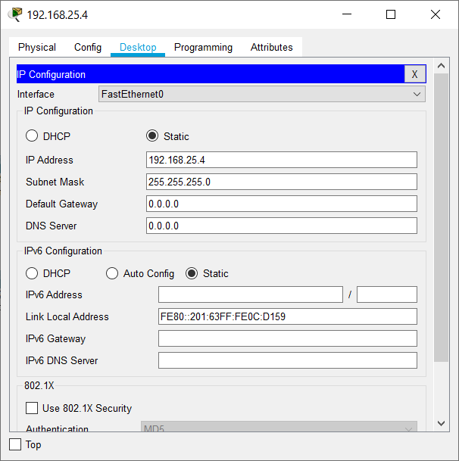

Ping Command

1. Click on the device.

2. Go to Desktop -> Command Prompt.

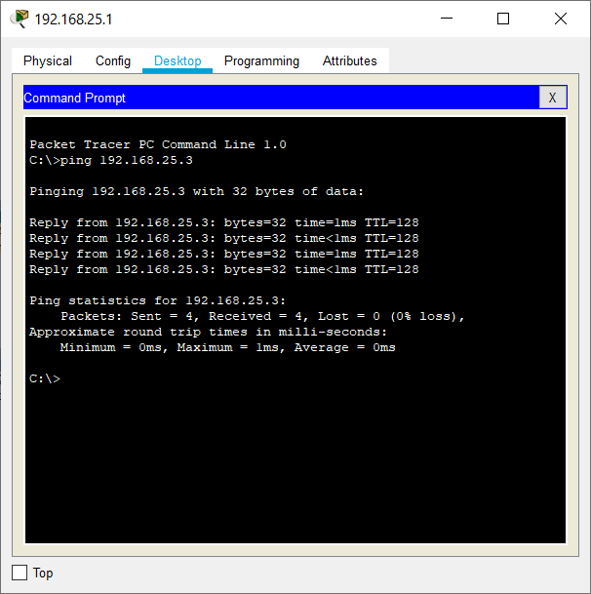3. Type ping ip_address.

Real Mode Simulation (Switch)

1. Click on simulation tab on bottom right corner.

2. Drop Simple PDU (P) on the source and destination.

3. Then click on the play button in the simulation window.

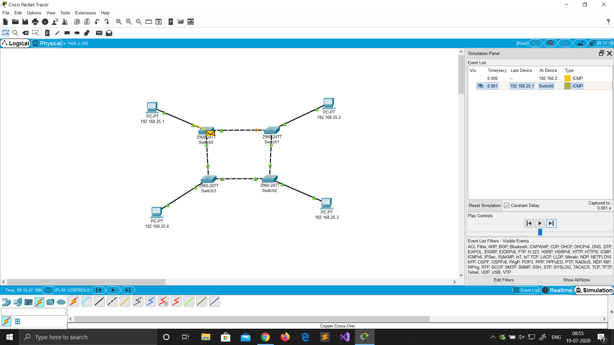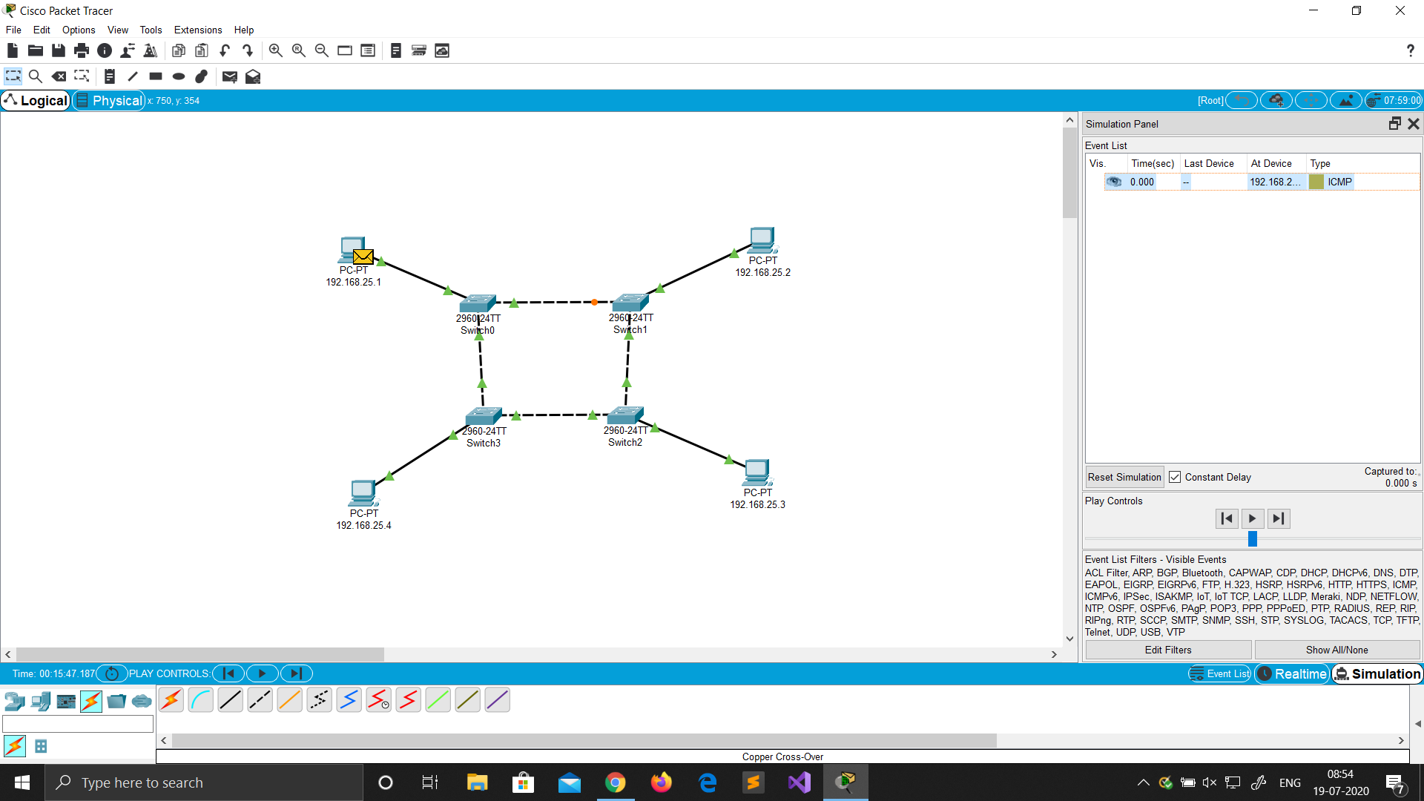

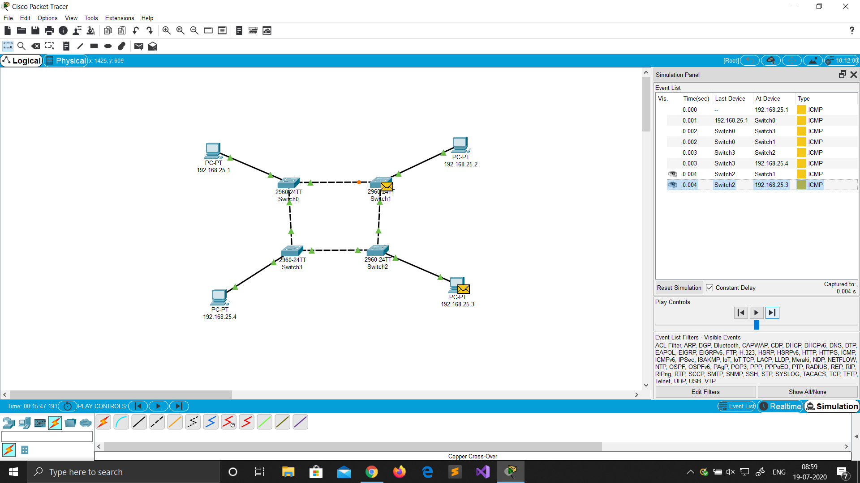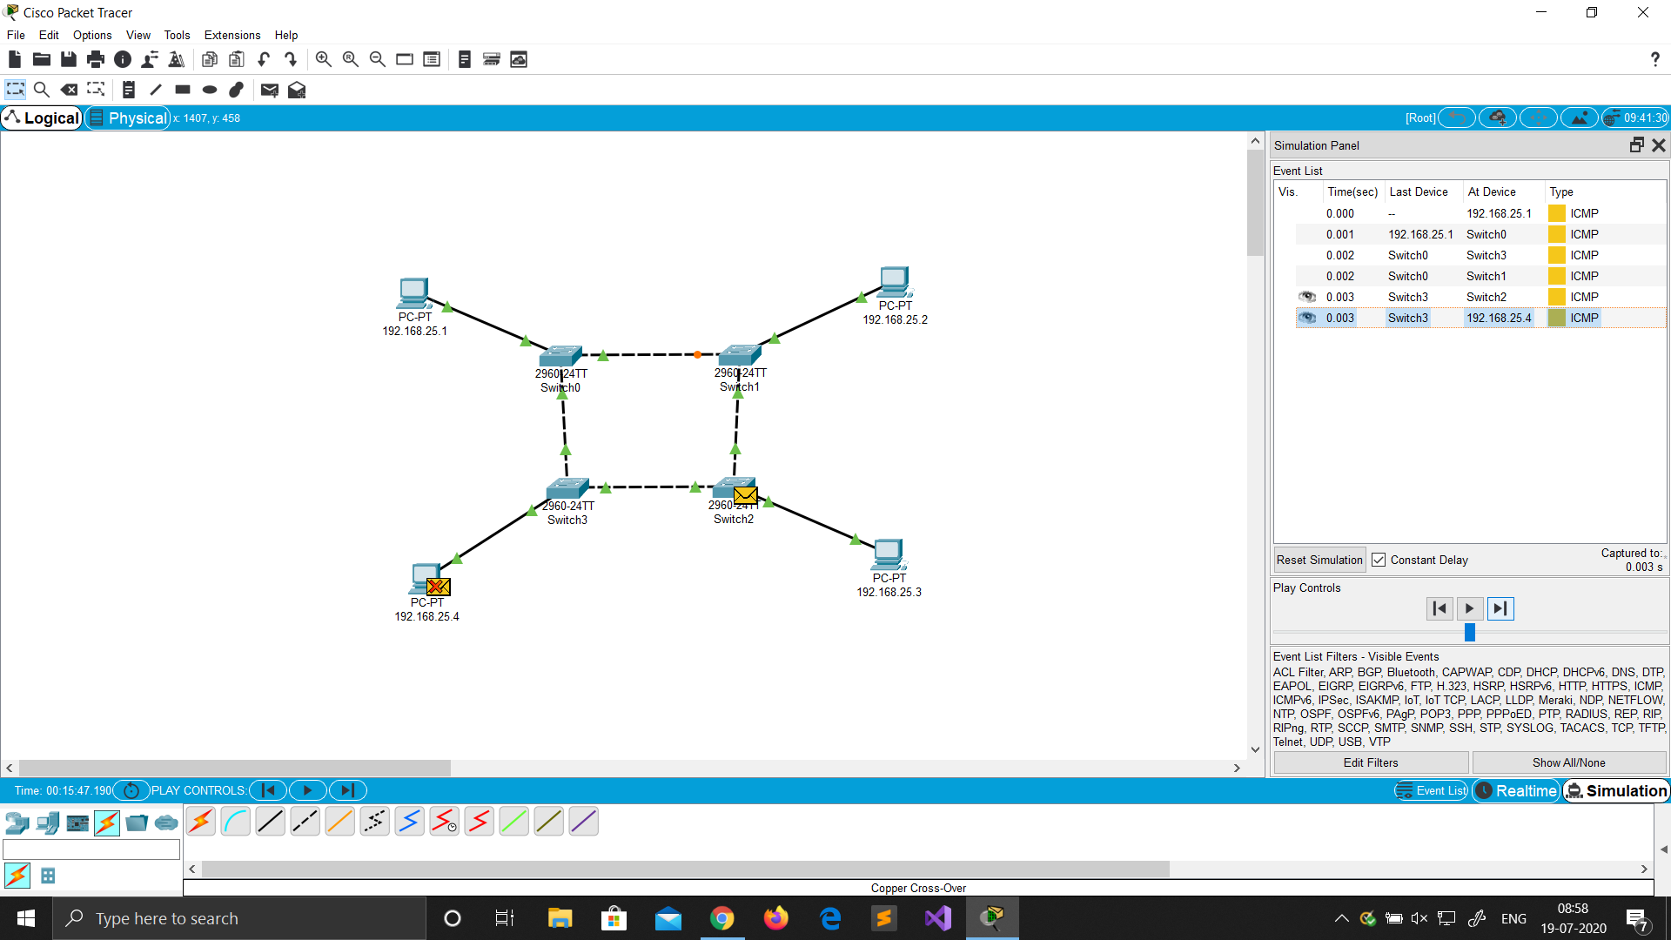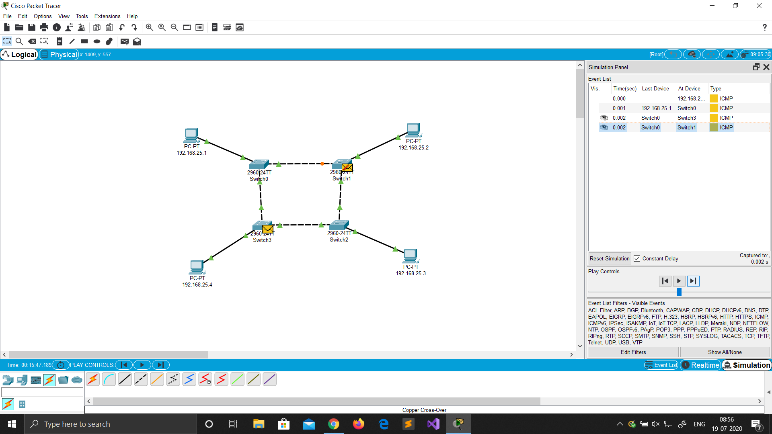

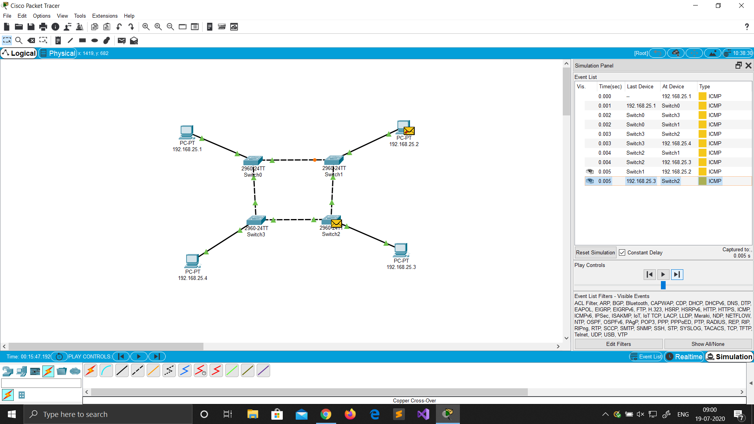

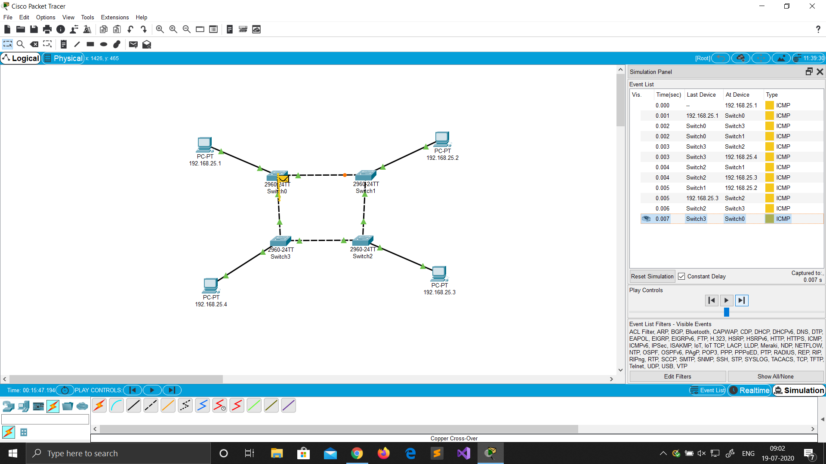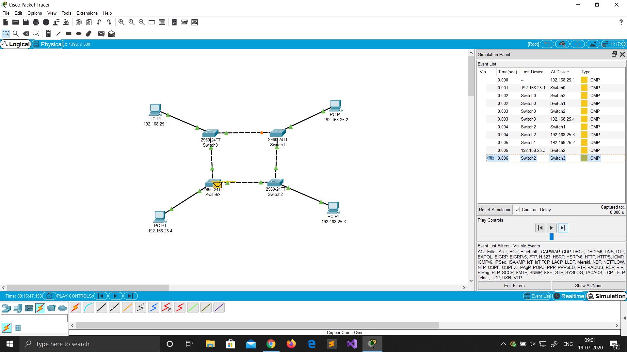

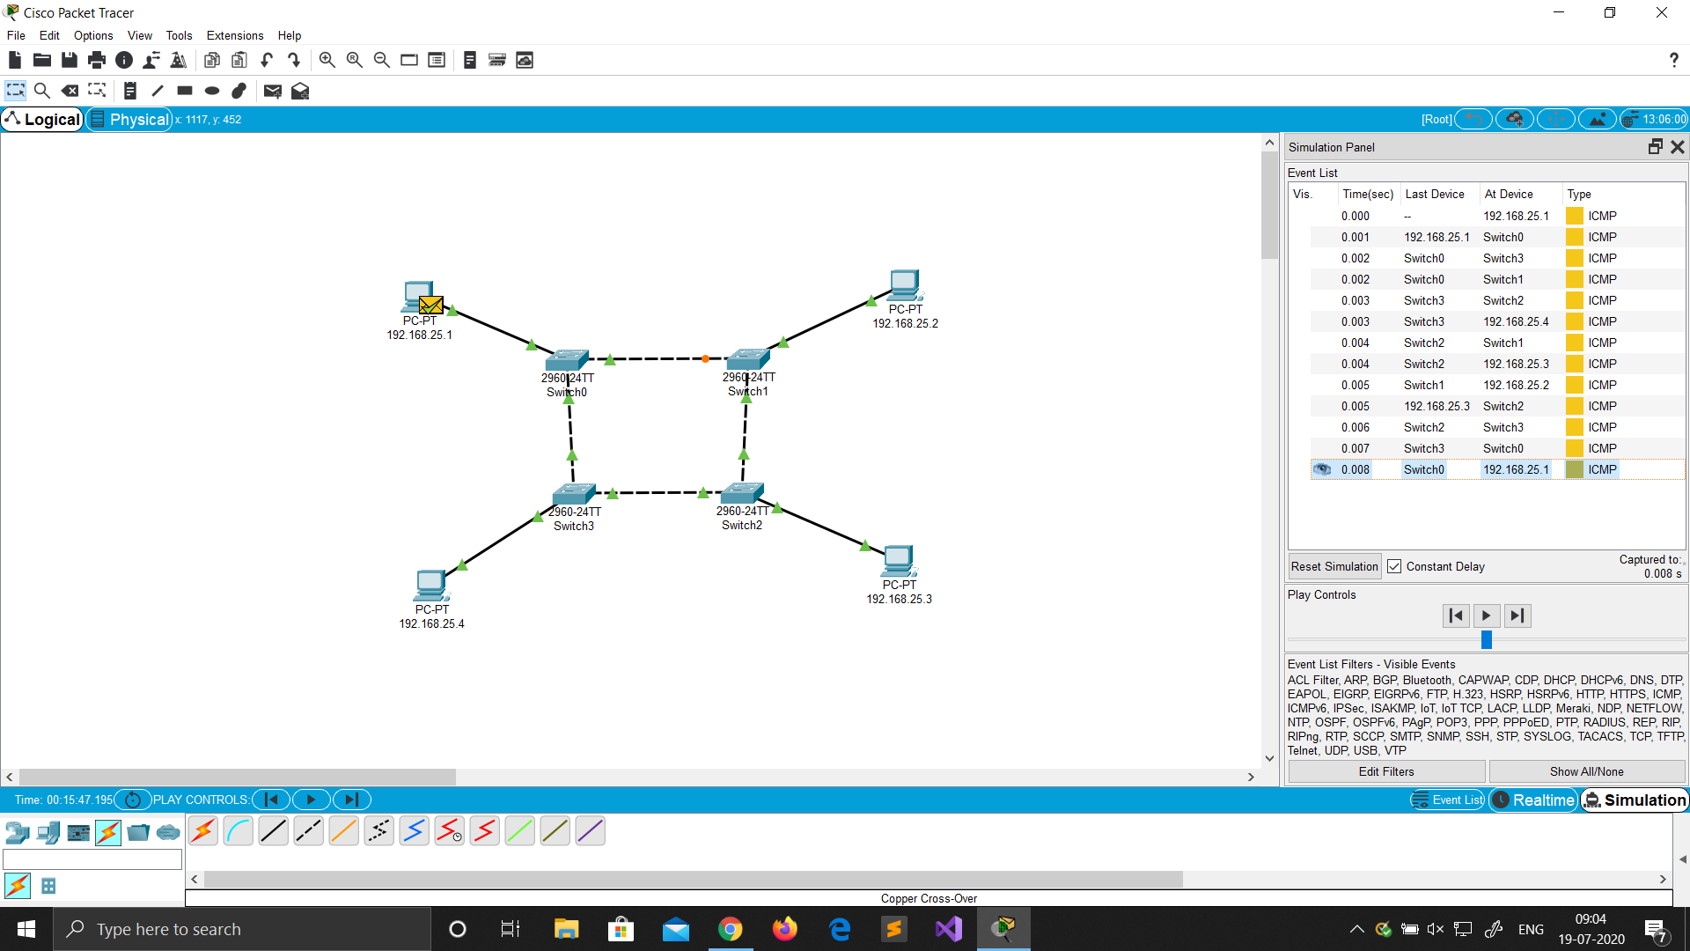

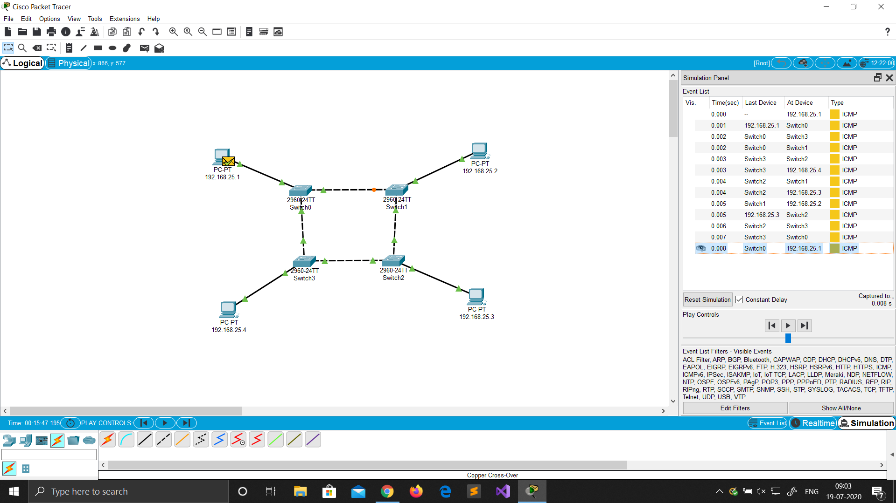

Advantages of Ring Topology

* Reduced chances of data collision as each node release a data packet after receiving the token.
* Token passing makes ring topology perform better than bus topology under heavy traffic
* No need of server to control connectivity among the nodes
* Equal access to the resources

Disadvantages of Ring Topology

* In Unidirectional Ring, a data packet must pass through all the nodes.

Ex: Let’s say A, B, C, D, and E are a part of the ring network. The data flow is from A towards B and henceforth. In this condition, if E wants to send a packet to D, the packet must traverse the entire network to reach D.

* Single point of failure, that means if a node goes down entire network goes down.

* **MESH TOPOLOGY**

In mesh topology every device has a dedicated point to point link to every other device. The term dedicated stand for link carries traffic only between two devices it connects. It is a well-connected topology; in this every node has a connection to every other node in the network. The cable requirements are high and it can include multiple topologies. Failure in one of the computers does not cause the network to break down, as they have alternative paths to other computers star topology, all the cables run from the computers to a central location.

Network Topology

1. Drag and drop PC from End Devices.

2. Connect them with Copper Straight through cable.

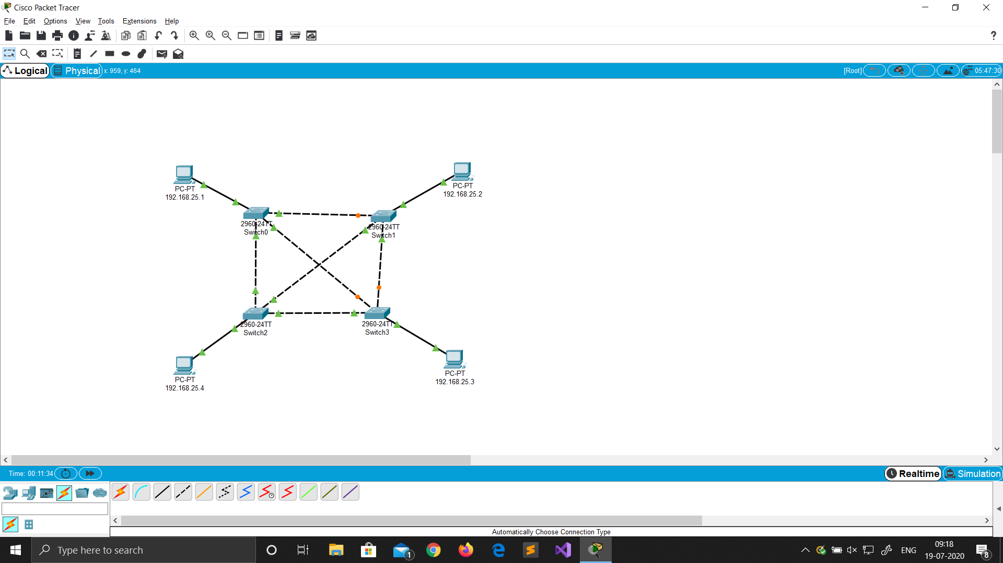3. Change display name with their IP addresses.

 Ip Address Configuration

1. Click on the device.

2. Go to Desktop ->IP configuration.

3. Set static IPs of all devices. No gateway required (same network).

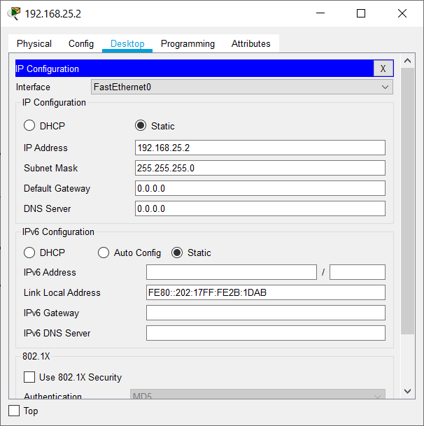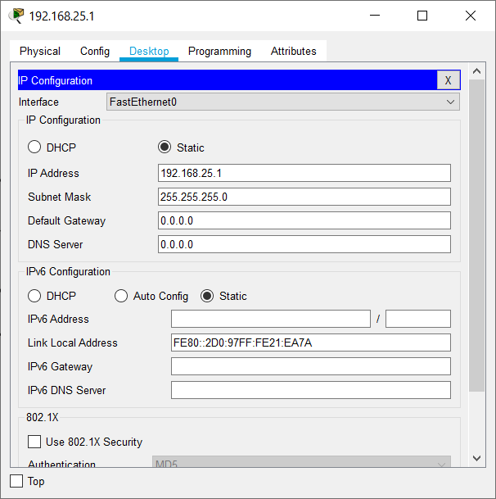

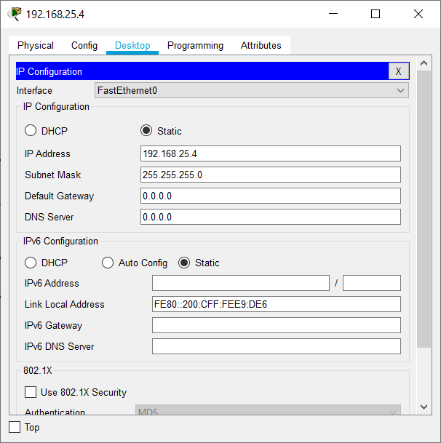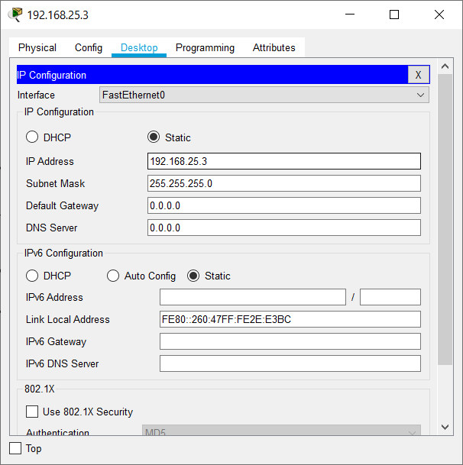

Ping Command

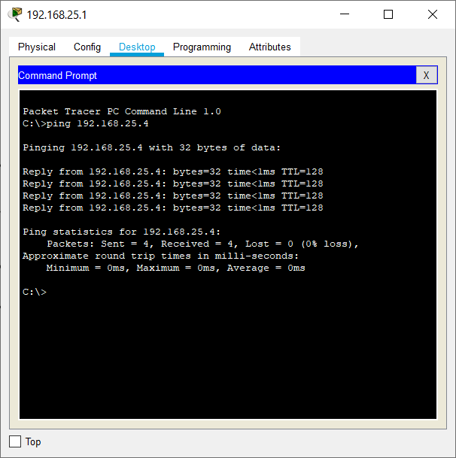1. Click on the device.

2. Go to Desktop -> Command Prompt.

3. Type ping ip_address.

Real Mode Simulation (Switch)

1. Click on simulation tab on bottom right corner.

2. Drop Simple PDU (P) on the source and destination.

3. Then click on the play button in the simulation window.

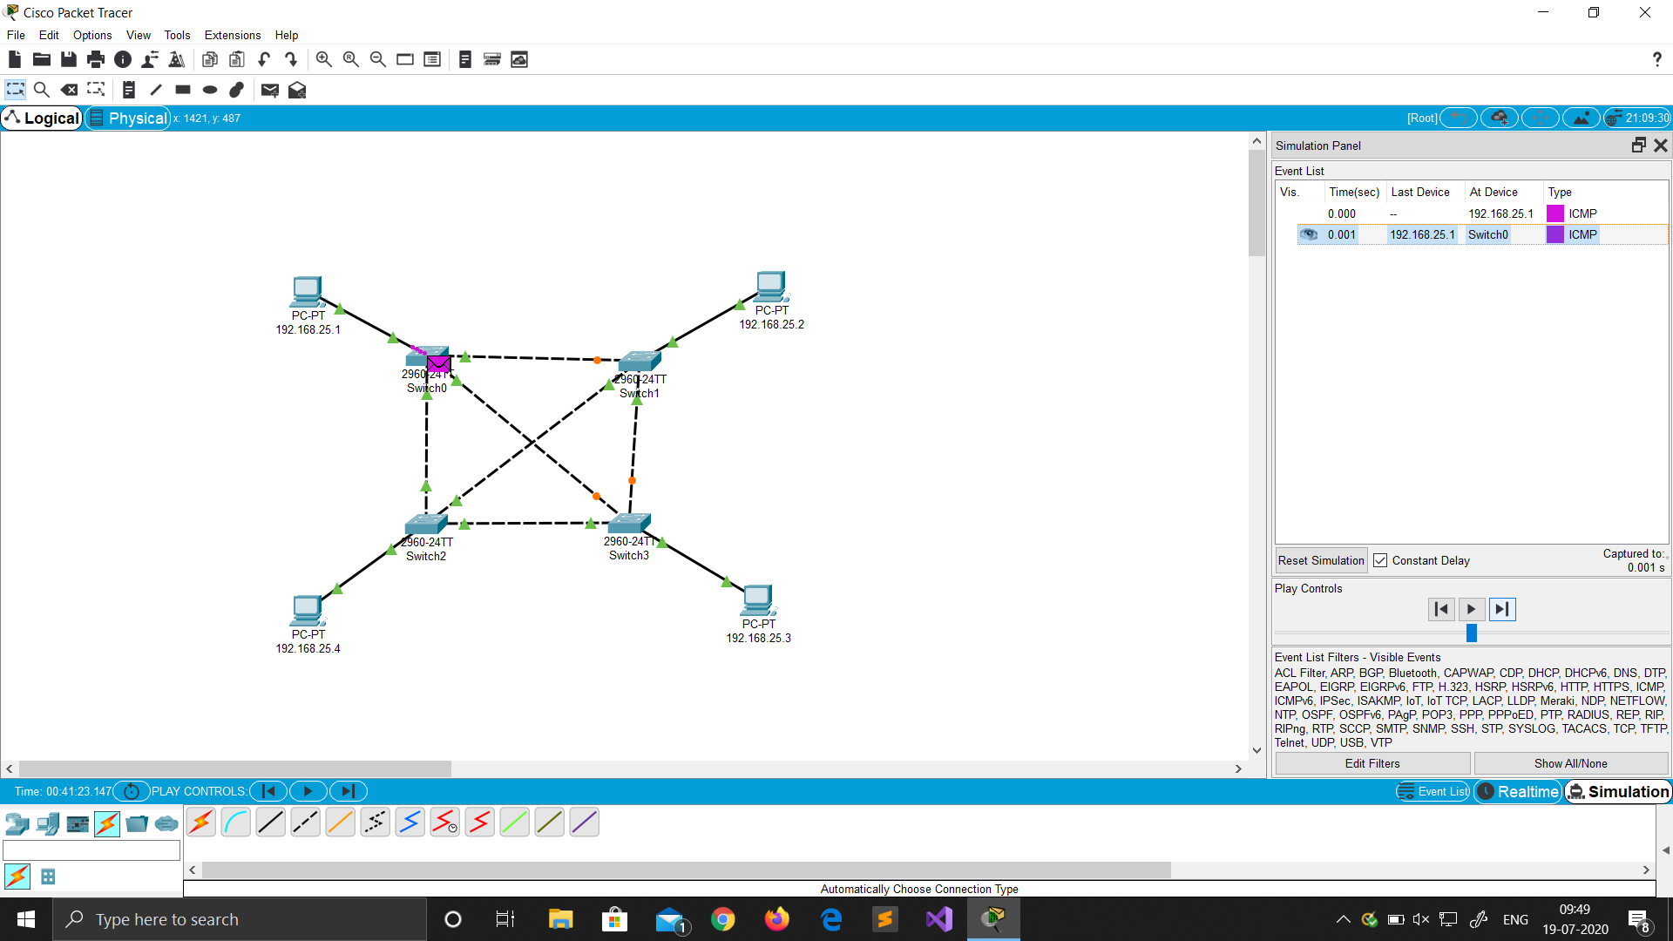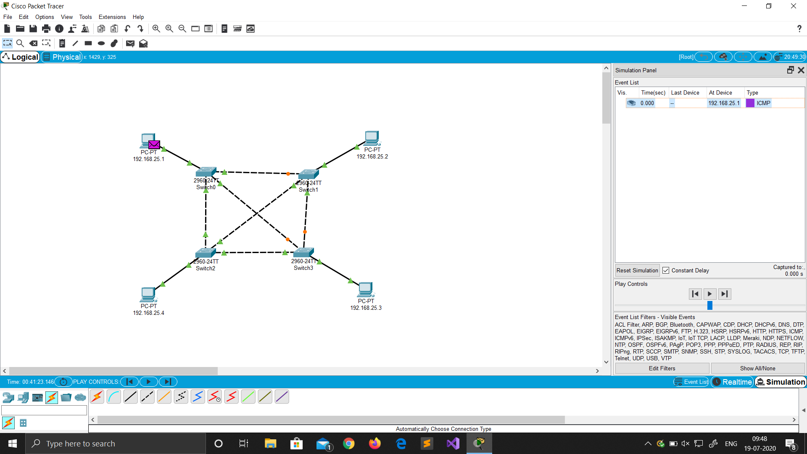

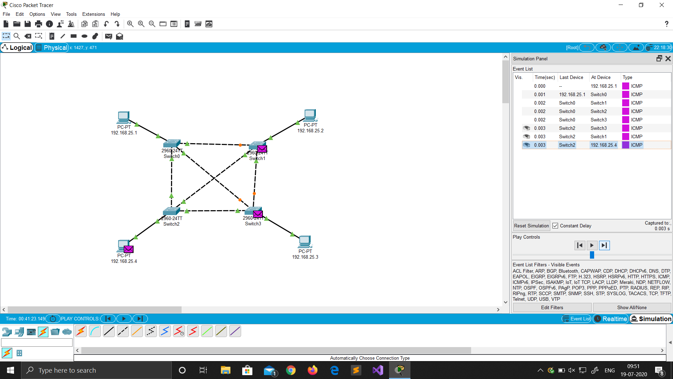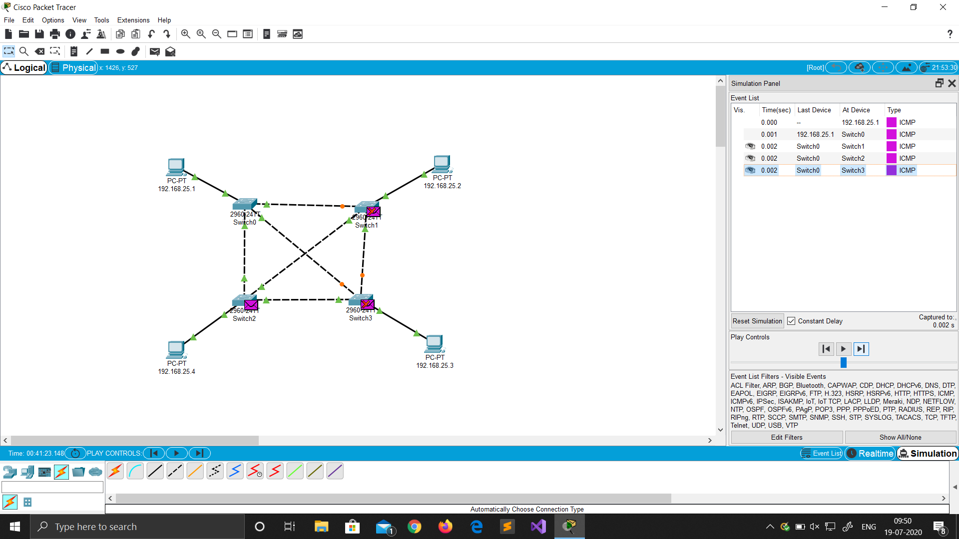

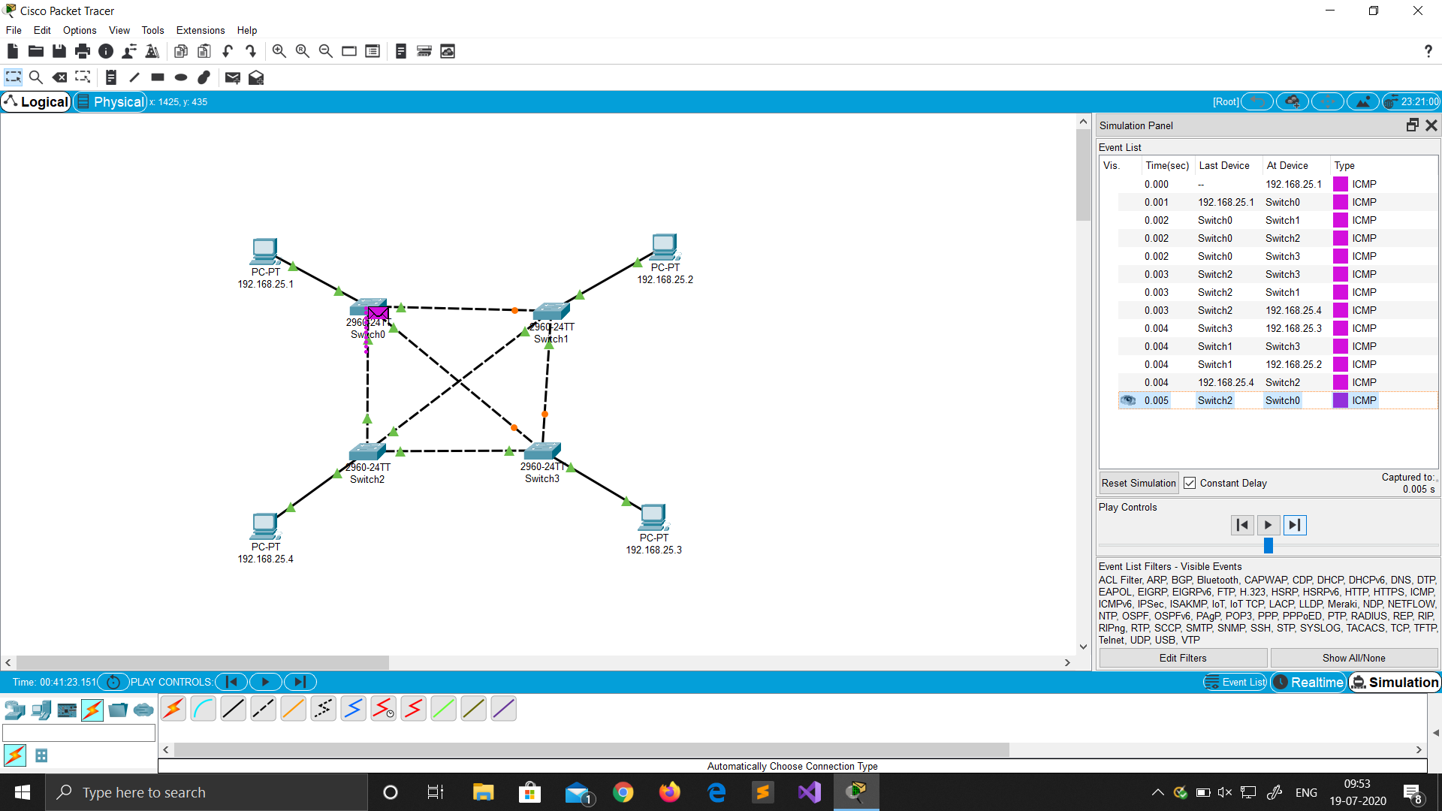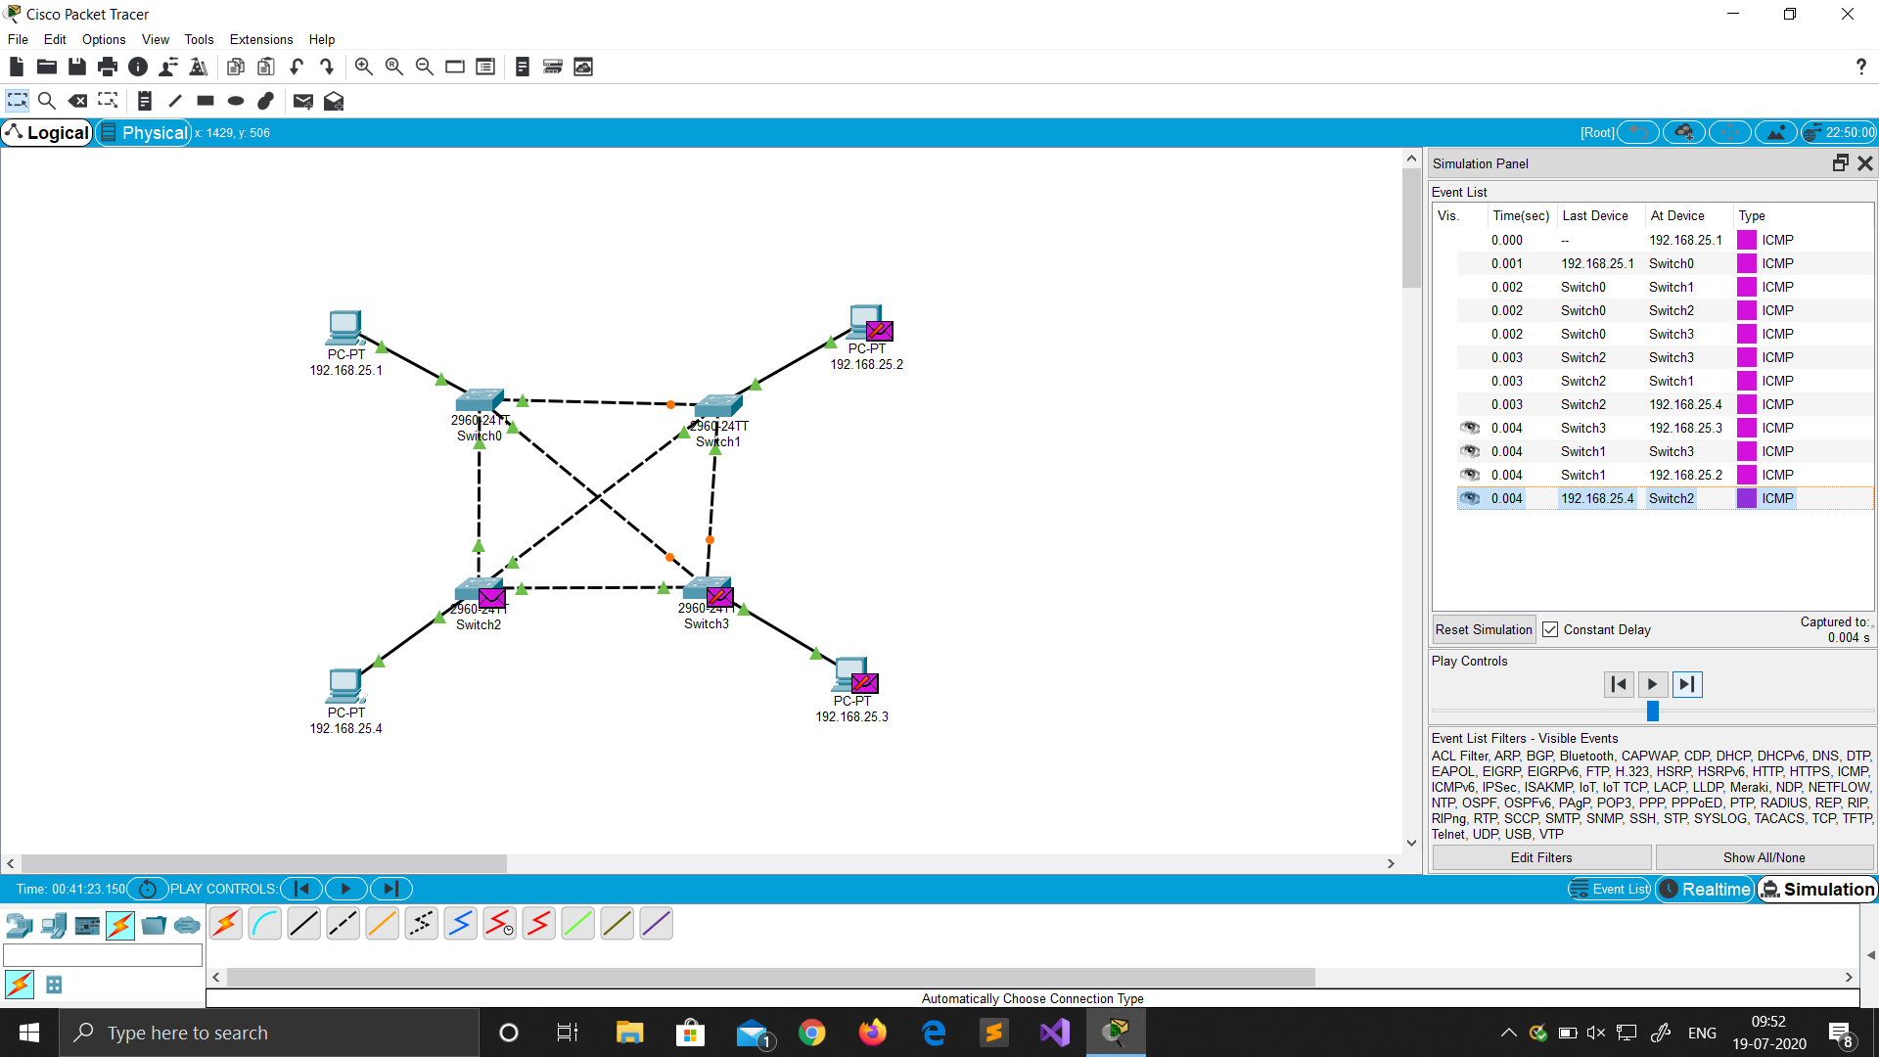

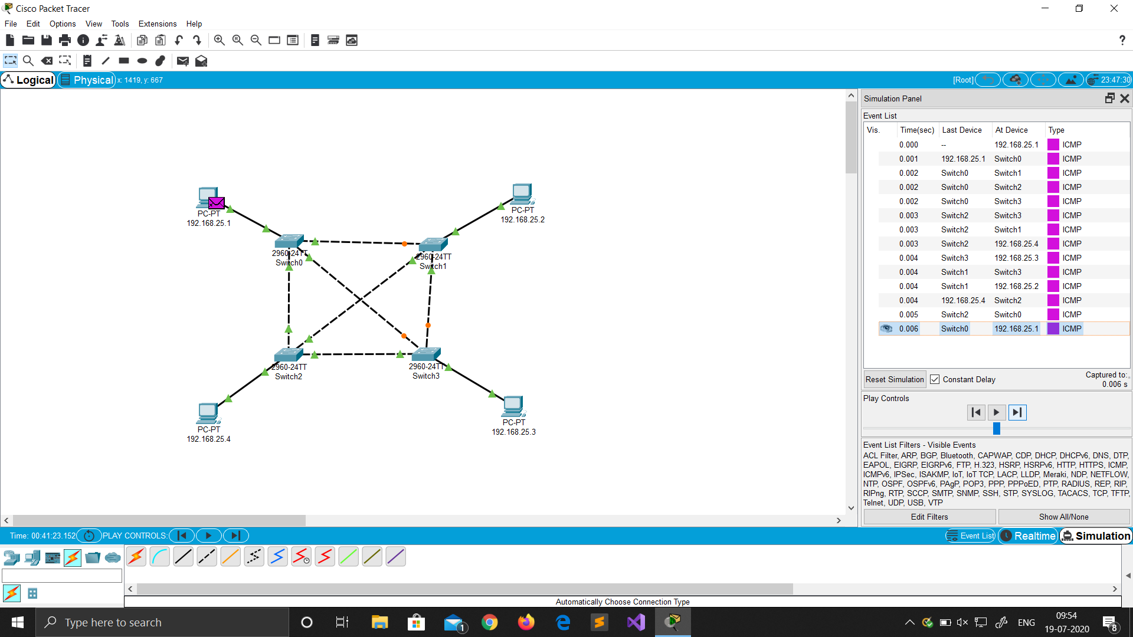

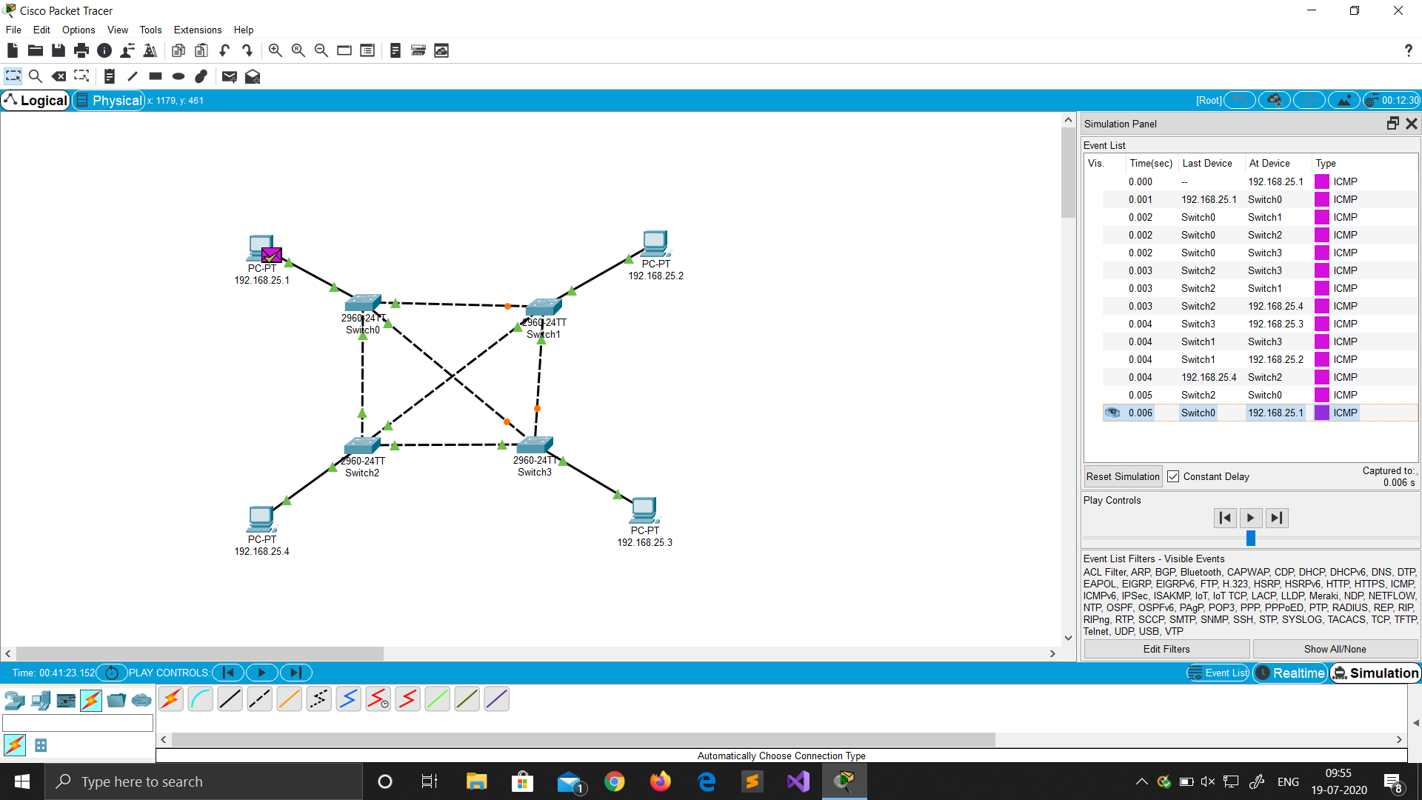

Advantages of Mesh Topology

* Each connection can carry its own data load
* It is robust
* A fault is diagnosed easily
* Provides security and privacy

Disadvantages of Mesh Topology

* Installation and configuration are difficult if the connectivity gets more
* Cabling cost is more and the most in case of a fully connected mesh topology
* Bulk wiring is required